|  |
| --- |
| SwapAgent: Cross currency swap  Proof of Concept |

|  |  |
| --- | --- |
| **Service:** | SwapClear |
| **Project/Area:** | SwapAgent: Cross currency swap |
| **Owner:** | Risk Change |
| **Document Type:** | Proof Of Concept |
| **Version Number:** | V3 |
| **Issue Date:** | May 2017 |

**COPYRIGHT**

The copyright in this work is vested in LCH.Clearnet Ltd and is issued in confidence for the purpose for which it is supplied. It must not be reproduced in whole or in part or used for tendering or manufacturing purposes except under an agreement or with the consent in writing of LCH.Clearnet Ltd and then only on the condition that this notice is included in any such reproduction. No information as to the contents or the subject matter of this document or any part thereof arising directly or indirectly there from shall be given orally or in writing or communicated in any manner whatsoever to any third party being an individual firm or employee thereof without the prior consent in writing of LCH.Clearnet Ltd..

© LCH.Clearnet Limited, 33 Aldgate High Street, London, EC3N 1EA

**LCH.Clearnet ONLY**

This document can be freely distributed within LCH.Clearnet but should not be copied outside the company without the agreement of the information owner.

**TRADEMARKS**

All trademarks are duly acknowledged.

SwapClear is a trademark of LCH.Clearnet Limited

ClearLink is a trademark of LCH.Clearnet Limited

Version History

|  |  |  |  |
| --- | --- | --- | --- |
| Version | Author | Description of Change | Date |
| 1.0 | Mohamed Dergueche | Initial draft | 26-04-2016 |
| 1.1 | Mehdi El Amrani | Updated appendix | 01-06-2016 |
| 1.2 | Mohamed Dergueche | FX Setting – Discounted MV | 05-06-2016 |
| 1.3 | Mehdi El Amrani | Modification of FX Setting – Discounted MV s | 09-06-2016 |
| 1.4 | Mohamed Dergueche | Updates after the feedback from Murex | 17-06-2016 |
| 1.5 | Mehdi El Amrani | FX fixing procedure update | 24-06-2016 |
| 2.0 | Mehdi El Amrani | Document structure revamping and addition of Cross currency swap types | 29-07-2016 |
| 2.1 | Mehdi El Amrani | DV01 par bug in v27 for Swap points pillar | 24-08-2016 |
| 3.0 | Salma Alozade | Retesting the new patch to ensure the corrections are working and no regression is observed | 15-15-2017 |

Table of Contents

1 Summary 7

1.1 Goal of the POC 7

1.2 Scope of the POC 7

1.3 Outcome of the POC 8

2 Basis curve 9

2.1 Basis curves definition 9

2.2 Synthetic curves 9

3 Analytical pricing and Risk formulas 12

3.1 Notations 12

3.2 Common formulas: 13

3.3 GBP-EUR Fixed-fixed cross currency swap: 14

3.4 EUR-USD cross currency basis swap: 16

3.5 EUR-USD resettable cross currency basis swap: 17

4 MX reconciliation: 21

4.1 GBP-EUR Fixed-Fixed cross currency basis swap: 21

4.2 EUR-USD cross currency basis swap: 23

4.3 Resettable cross currency basis swap 26

4.4 EUR-USD resettable cross currency basis swap: NPV and Risk Post trade inception 28

5 Required MX configuration: 33

5.1 Basis curve as an outright curve: 33

5.2 FX cross sensitivities 33

5.3 Rate/Rate propagation 34

5.4 FX router and FX curve assignments: 35

5.5 FX conversion settings: 35

5.6 FX delta- Simulation viewer output configuration 36

6 Gaps/ unexpected behaviours: 39

6.1 Gaps: 39

6.2 Unexpected behaviours: 39

7 Patch 3.1.27.16.en.10 and corrections: 41

7.1 Settings and configuration 41

7.2 Cross currency basis curve calibration 43

7.3 Cross currency basis curve Jacobean 44

7.4 Resettable cross currency basis swap (Float-Float) 46

7.5 Cross currency basis swap (Fix-Fix) 50

7.5 Non regression tests with the slash 52

Appendix 1 – List of closed Murex cases 56

Appendix 2 – Basis curve defined as a spread curve 57

Table of Figures

Figure 1: Basis curves dependencies 9

Figure 2: GBP-EUR Fixed-Fixed Xccy swap 14

Figure 3: EUR-USD Xccy swap 16

Figure 4: Resettable EUR-USD Xccy swap 18

Figure 5: GBP-EUR Fixed Fixed Xccy trade definition 21

Figure 6: GBP-EUR Fixed Fixed Xccy NPV matching results 22

Figure 7:GBP-EUR Fixed Fixed Xccy IR delta discount GBP leg matching results 22

Figure 8: GBP-EUR Fixed Fixed Xccy IR delta discount EUR leg matching results 23

Figure 9: GBP-EUR Fixed Fixed Xccy FX spot conversion IR risk-GBP leg matching results 23

Figure 10: GBP-EUR Fixed Fixed Xccy FX spot conversion IR risk-EUR leg matching results 23

Figure 11: GBP-EUR Fixed Fixed Xccy FX delta matching results; 23

Figure 12: EUR-USD Xccy trade definition 24

Figure 13: EUR-USD Xccy NPV matching results 24

Figure 14: EUR-USD Xccy IR delta matching results 25

Figure 15: EUR-USD Xccy FX spot conversion IR risk matching results 25

Figure 16: EUR-USD Xccy FX delta matching results 26

Figure 17: Total IR Risk 26

Figure 18: Resettable EUR-USD Xccy trade definition 27

Figure 19: Resettable EUR-USD Xccy IR delta matching results 28

Figure 20: Resettable EUR-USD Xccy FX delta matching results 28

Figure 21: Resettable EUR-USD Xccy Trade definition 29

Figure 22: FX delta coming from EUR leg before FX fixing 29

Figure 23: FX delta of USD interest flows before FX fixing 29

Figure 24: FX delta of USD outstanding capital before FX fixing 30

Figure 26: FX delta of USD interest flow after FX fixing 30

Figure 25: Total FX delta before FX fixing 30

Figure 27: FX delta of USD outstanding capital after FX fixing 31

Figure 28: Total FX delta after FX fixing 31

Figure 29: Cash flows representation after FX reset date 31

Figure 30: Deal ticket 32

Figure 31: FX delta contribution after FX reset date 32

Figure 32: Basis curve settings 33

Figure 33: Default entry curve specific setting 34

Figure 34: DV01 discounting risk projected on USD libor 3M due to cross senstivities 34

Figure 35: Rate/Rate propagation setting 35

Figure 36: FX routers definition 35

Figure 37: FX curves assignment 35

Figure 38: General FX setting of Spot conversion 36

Figure 39: Simulation setting of FX spot conversion 36

Figure 40: FX delta- Simulation viewer output configuration 37

Figure 41: "Flow" setting 37

Figure 42: Past Cash is counted in FX delta 37

Figure 43: Only MV is considered in FX delta 38

Figure 44: Basis Curve - Wrong Dependency 39

Figure 45: FX delta projected in two different outputs 40

Figure 46 : Default entry setting 41

Figure 47: Slash /XCCY_SENSIS_FOLLOW_PROPAGATION: 42

Figure 48 : FX indexation evaluate using setting 42

Figure 49: EUR USD BASIS calibration non regression matching results 43

Figure 50: ZC replication for 1M pillar matching results 43

Figure 51: ZC replication for 6M pillar matching results 44

Figure 52: ZC replication for 9M pillar matching results 44

Figure 53: EUR USD BASIS dNPV/dZ Swap point issue 44

Figure 54: EUR USD BASIS dZ/dR Swap point issue 45

Figure 55: EUR USD BASIS dNPV/dZ Swap point correction 45

Figure 56: EUR USD BASIS dZ/dR Swap point correction 45

Figure 57: EUR USD BASIS Simplified curve Jacobian matching results 46

Figure 58: EUR-USD 3M-3M MTM trade definition 47

Figure 59: EUR-USD 3M-3M MTM NPV matching results 47

Figure 60: EUR-USD 3M-3M MTM Discount DV01 EUR leg matching results 48

Figure 61: EUR-USD 3M-3M MTM Forward DV01 EUR leg matching results 48

Figure 62: EUR-USD 3M-3M MTM FX spot conversion DV01 EUR leg matching results 48

Figure 63: EUR-USD 3M-3M MTM Discount DV01 USD leg matching results 49

Figure 64: EUR-USD 3M-3M MTM Forward DV01 USD leg matching results 49

Figure 65: EUR-USD 3M-3M MTM FX Fwd DV01 USD leg matching results 49

Figure 66: EUR-USD 3M-3M MTM PV01 matching results 50

Figure 67: EUR-USD 3M-3M MTM FX delta EUR leg matching results 50

Figure 68: EUR-USD 3M-3M MTM FX delta USD leg matching results 50

Figure 69: GBP-EUR FIX-FIX between versions NPV matching results 51

Figure 70: GBP-EUR FIX-FIX between versions DV01 EUR leg matching results 51

Figure 71: GBP-EUR FIX-FIX between versions DV01 USD leg matching results 51

Figure 72: GBP-EUR FIX-FIX between versions FX delta matching results 52

Figure 73: No-slash and default entry set to zero coupon 52

Figure 74: Slash and default entry set to market rates 53

Figure 75: EUR-USD 3M-3M MTM with both settings configuration matching results 54

Figure 76: EUR-USD 3M-3M with both settings configuration matching results 54

Figure 77: EUR-USD FIX-FIX MTM with both settings configuration matching results 55

Figure 78: GBP-EUR FIX-FIX with both settings configuration matching results 55

Figure 79: IR risk with basis curve defined as an outright curve 57

Figure 80: IR risk with basis curve defined as a spread curve 57

# Summary

## Goal of the POC

The goal of this proof of concept is to show if Murex can evaluate different type of cross currency basis swap product. It covers as well the computation of interest rate risk and foreign exchange risk using “Local currency – USD” basis curve.

## Scope of the POC

The exercise is run on the current LCH Murex version i.e. v3.1.27.16. It will be done in the VM space (*EOD Main* Market Data Set) which means that the pricing will be in a multi-curve world, the interest rate risk is however based on the hypothesis that the dependencies between rate curves are broken i.e. No propagation effect and no cross sensitivities are considered.

All trades are collateralized in USD in first phases of SwapAgent project for cross currency basis swap products and this statement is valid for this POC.

The following table describes the different cross currency basis swap products:

|  |  |  |  |  |
| --- | --- | --- | --- | --- |
| **Product** | **Coupon Flows** | **Quotation** | **FX Rate** | **Notional Flows** |
| **Resettable Cross Currency Basis Swap** | Floating Rate 3m Index (foreign ccy) vs 3m USD Libor | Spread, in basis points, over foreign currency index | Variable every 3 months. USD amount cash-settled. | Initial and Final Exchange of notional |
| **Cross Currency Basis Swap** | Floating Rate 3m Index (foreign ccy) vs 3m USD Libor | Spread, in basis points, over foreign currency index | Agreed at time of trading. Same rate used for both initial and final exchange | Initial and Final Exchange of notional |
| **Fixed-Fixed** | Fixed Rate (foreign) vs Fixed Rate (domestic) | Customisable | Agreed at time of trading. Same rate used for both initial and final exchange | Initial and Final Exchange of notional |
| **Fixed-Float** | Fixed Rate vs Floating Rate | Spread over floating rate | Agreed at time of trading. Same rate used for both initial and final exchange | Initial and Final Exchange of notional |

The following specific cases are sufficient coverage for this POC:

* GBP-EUR fixed-fixed cross currency basis swap
* EUR-USD cross currency basis swap
* EUR-USD resettable cross currency swap

Rate curve assignment will hence be:

|  |  |  |  |  |  |  |
| --- | --- | --- | --- | --- | --- | --- |
| **Type** | **Currency** | | **Discounting curve** | | **Forward curve** | |
| Leg1 | Leg2 | Leg1 | Leg2 | Leg1 | Leg2 |
| **Fixed-Fixed** | EUR | GBP | EUR USD BASIS | GBP USD BASIS | - | - |
| **Resettable** | EUR | USD | EUR USD BASIS | USD FEDFUND | EUR EURIBOR 3M | USD LIBOR 3M |
| **Non-resettable** | EUR | USD | EUR USD BASIS | USD FEDFUND | EUR EURIBOR 3M | USD LIBOR 3M |

Note that basis curves are outright curves and are not configured as spread curves on another OIS curves, they calibrate a total ZC directly from its own instruments. Note as well that those curves are considered as a FX curves and a discounting curves in the same time.

It is worth also noting that linear zero coupon rate interpolation is used for both pricing and risks evaluation for simplicity reason, Murex natural cubic spline interpolation on the log of discount factors algorithm has previously been validated.

Murex pricer (e-tradepad) and the simulation are the main screens used for the validation.

This POC does not give any proof about the capability of Murex on IM calculation nor for non-USD collateralisation currency. This will be done in a separate POC.

Not as well that Interest rate gamma is not planned to be validated.

## Outcome of the POC

* Basis curve: Basis curves calibrate correctly with resettable cross currency basis swaps as pillars.
* Evaluation: NPV for all types of cross currency basis swap is correctly reconciled and forward FX rate is correctly estimated using the assigned FX curves.
* Zero IR deltas: The zero deltas are matching the theoretical calculation which is based on direct sensitivities (ignoring FX cross sensitivities). There is a very small mismatch described in section 6.2.2 that can be ignored.
* PAR IR deltas: The PAR IR deltas are retrieved based on the Zero IR delta and the Jacobean matrix. However, Jacobean matrix is wrongly computed when FX swaps are components of a rate curve (section 6.1.2).=> corrected in the patch 3.1.27.16.en.10 (see section 7)
* FX Delta for “Local currency-USD” cross currency basis swaps: The theoretical calculation is in line with what Murex is producing.
* FX Delta for “Local currency- Local currency” cross currency basis swaps: FX deltas are reconciled but are projected in different outputs. This needs to be taking into account when building the risk report (section 6.2.1).
* FX delta is consistent during the trade lifecycle and the FX fixing procedure is correctly called.

It is worth mentioning that Murex is not able to handle non-USD collateralisation (section 2.2).

# Basis curve

## Basis curves definition

New basis curves will be defined is order to represent the foreign funding curve for non-USD currencies. Those curves will be used as discounting curves in the cross currency swap and as FX curves in order to estimate forward FX rates.

The instruments used in those curves will be:

* Swap Points (FX swaps) for the short end (O/N up to 18 Months)
* Resettable cross currency Basis Swaps for the long term of the curve (2Y to 30Y).

EUR USD Basis curve and GBP USD Basis curve will be configured with regard to the POC’s scope, below schemas showing their dependencies to existing curves as per the rate curve assignments:

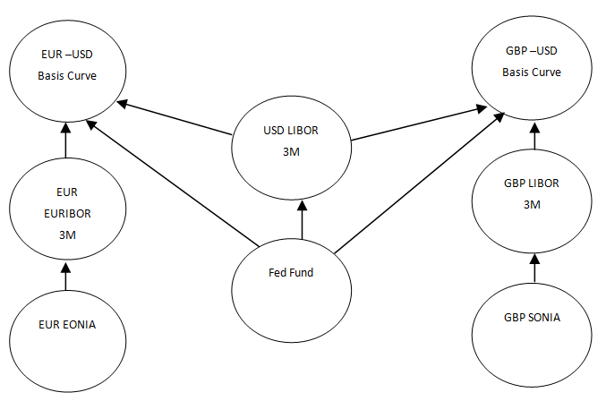

Figure : Basis curves dependencies

A B : Curve B calls the zero coupons of curve A when calibrating

## Synthetic curves

Non-USD currency is not planned to be used as a collateralisation currency in first phases of SwapAgent. However, the following paragraphs illustrate the notion of synthetic curves and shows Murex coverage on the subject.

### Collateralisation in non-USD currency:

USD is considered the “pivot” currency for the currency pairs of SwapAgent scope. “Local currency-USD” FX swaps and resettable cross currency swaps are the most liquid FX product in the market and considering “Local currency –USD” basis curves as “foreign” funding curves are legit.

“Local currency-USD” basis curve is the discounting curve for the local currency leg of a cross currency swap when USD is the collateralisation currency. However, and in order to respect the non-arbitrage logic, synthetic curves are needed as discounting curves when the collateralisation currency is in local currency.

It is important to note that the synthetic curves have the following characteristics:

* They have has no instruments; there are no calibration processes within the curves, only interpolation at specific dates.
* The synthetic curves do not bear or generate any risk on itself, but projects the risk onto three underlying curves (two FX curves and a funding curve).

Below examples of discounting curve assignment depending on the collateralisation currency:

|  |  |  |  |  |
| --- | --- | --- | --- | --- |
| **Currency** | | Top of Form  **Collateralisation**  Bottom of Form | **Discounting curve** | |
| **Leg1** | **Leg2** | Top of Form  **currency**  Bottom of Form | **leg1** | **leg2** |
| **EUR** | **USD** | USD | EUR USD Basis | USD FedFund |
| **EUR** | **USD** | EUR | EUR EONIA | USD-EUR implied |

### The logic behind synthetic curves

The NPV of a USD flow taking into account the funding at EUR collateral rate can be written as:

$${NPV}_{USD}= {Flow}_{USD}×{DF}_{USD-EUR synthetic}$$

The NPV of the same flow can be converted in EUR at payment date using the FX forward rate picked up by the two corresponding FX curves. The flow is then discounted at the funding rate which is the EUR EONIA and then converted back to USD using the FX spot rate:

$${NPV}_{USD}= {Flow}_{USD}×{{FX}_{Fwd}^{USD-EUR}×DF}_{EONIA}×{FX}_{Spot}^{EUR-USD}$$

With $${FX}_{Fwd}^{EUR-USD}= {FX}_{Spot}^{EUR-USD}×\frac{{DF}_{EUR-USD basis}}{{DF}_{Fedfund}}$$

By equalizing the above equations, the below formula is retrieved

$${DF}_{USD-EUR synthetic}= \frac{{DF}_{Fedfund}}{{DF}_{EUR-USD basis}}{×DF}_{EONIA}$$

### Murex “collateral based discounting” module

Murex has developed a collateral based discounting module (known as CSA module) that enables to assign the correct discounting curve depending on the collateralisation currency. The discounting curve can be the OIS curve if the discount is done in the local currency, the FX curve, or finally the synthetic curve.

This module enables to imply (on-the-fly) those synthetic curves based on a linear combination of existing curves and market data.

However, this module is available in higher version starting v3.1.30 (current version is v3.1.27).

### Is there a workaround solution in the current version?

The proposed workaround would consist of creating an inbound-outbound interface where the synthetic curve is calibrated outside Murex and fed back to Murex with “New dummy” calibrated quotes.

However, this proposal has several limitations and is heavy to implement. Listed below the drawbacks compared to the CSA module solution:

* The NPV is not accurate as the discounting factors of the synthetic curve won’t correctly be interpolated.
* IR risk (Par and Zero) is meaningless as the link to “real” curves is lost, while risk will be automatically projected to the real curve with CSA module.
* There is non-evaluated cost and risk to develop the solution outside Murex.
* Heavy additional configuration required.
* Additional workflows are required in order to mitigate operational risk.

For the above reasons, Risk team highly recommends the use of native Murex CSA module after the binary upgrade project for non-USD collateralisation.

# Analytical pricing and Risk formulas

Detailed formula used to reconcile Murex is described in this section

## Notations

Let’s denote the following (these notations will be used along the entire document):

* $t_{i} :$ Flow date. This can be the start, end or forward evaluation date for a given period
* n: Number of the interest flows periods in the trade
* today’s date is noted $t_{today}$
* i=0 corresponds to settlement date or spot date
* $F_{i}^{curve }$: The forward rate based on the forward curve used for a period i between $t_{i}-1$ and $t_{i}$ with i in $⟦1,n⟧$
* $r^{ccy}:$ Fixed rate of ccy leg
* ${Bs}_{ccy}$: Basis spread added to the floating rate
* $N_{i}^{ccy}$: Nominal expressed in currency to calculate the interest flow for the period i with i in $⟦0,n-1⟧$
* ${DF}_{i}^{curve}:$ The discount factor calculated from a curve between ${ t}_{i} and t_{today}$. It is following the exponential convention.
* ${FX}_{Spot}^{ccy1-ccy2}$: $ccy1-ccy2$ FX spot rate.
* ${FX}_{Disc}^{ccy1-ccy2}: ccy1-ccy2$ FX discounted spot rate.
* $∆_{i}^{flow}$: Accrual factor used in interest flows calculation
* $∆_{i}^{fwd}$: Accrual factor used in Libor and Euribor forward calculation
* $∆_{i}^{Curve}:$ Accrual factor used in discount factor calculation
${NPV}_{ccy}^{t_{i}}:Net Present Value of the cross currency swap expressed in currency '{ccy}^{'}as of t_{i}$

* ${DV01}_{type}^{curve}$: Total of the interest rate delta coming from +1 basis point shift of the zero rates of the curve. The ‘*type’* is to differentiate between discounting, forward, FX forward or FX spot conversion risk
* ${[DV01]}^{curve}$: Zero IR delta vector projected on curve’s pillars dates
* ${DV01}_{PAR}^{curve}$: Total of the interest rate risk coming from +1 basis point shift of the market quoted of the curve.
* ${[DV01]}_{PAR}^{curve}:$ Par IR delta vector
* ${[\frac{dZ}{dR}]}^{curve}$: The Jacobean matrix of the curve

$δ_{in}: Kronecker symbol$

## Common formulas:

### Forward rate:

The forward rate calculation is supposing that a linear convention is used:

$$F_{i}^{curve }= \frac{1}{∆_{i}^{fwd}}×\left(\frac{{DF}_{i-1}^{curve}}{{DF}_{i}^{curve}}-1\right)$$

### FX rate discounted:

$${FX}_{Disc}^{ccy1-ccy2}={FX}_{Spot}^{ccy1-ccy2}×\frac{{DF}_{0}^{ccy2 FX curve}}{{DF}_{0}^{ccy1 FX curve}}$$

### Forward FX rate:

$${FX}_{{Fwd}_{i}}^{ccy1-ccy2}={FX}_{Spot}^{ccy1-ccy2}×\frac{{DF}_{i}^{ccy1 FX curve}}{{DF}_{i}^{ccy2 FX curve}}×\frac{{DF}_{0}^{ccy2 FX curve}}{{DF}_{0}^{ccy1 FX curve}}$$

### Par IR delta:

Par IR delta is based on zero IR delta projected on curve pillars multiplied by the Jacobean matrix of the curve

$${[DV01]}_{PAR}^{curve}={[DV01]}^{curve}×{[\frac{dZ}{dR}]}^{curve}$$

### FX spot conversion IR risk:

This is a very small risk that appears when converting the NPV of local currency leg to USD using the discounted FX rate. It is illustrated in the below example:

For a EUR-USD cross currency basis swap collateralised in USD, forward risk will appear due to the conversion of NPV of the EUR leg to USD using FX discounted rate

$${NPV}_{expressed in USD}^{EUR-Leg}={NPV}_{today}^{EUR-Leg}*{FX}_{Spot}^{EUR/USD}*\frac{{DF}_{0}^{Fed}}{{DF}_{0}^{EUR Basis}}$$

The risk is hence expressed on the two FX curves:

USD FedFund:

$${DV01}_{{FX}_{spot}}^{Fed}=-{NPV}_{today}^{EUR-Leg}*{FX}_{Spot}^{EUR/USD}*∆_{0}^{Fed}*\frac{{DF}_{0}^{Fed}}{{DF}_{0}^{EUR Basis}}$$

EUR USD Basis:

$${DV01}_{{FX}_{spot}}^{EUR basis}={NPV}_{today}^{EUR-Leg}*{FX}_{Spot}^{EUR/USD}*∆_{0}^{Basis}*\frac{{DF}_{0}^{Fed}}{{DF}_{0}^{EUR Basis}}$$

${DV01}_{{FX Fwd}_{spot}}^{EUR basis}$ is still expressed in USD at this stage. It should still be converted to EUR using the discounted FX rate

Hence

$${DV01}_{{FX}_{spot}}^{EUR basis}={NPV}_{today}^{EUR-Leg}*∆_{0}^{Basis}$$

## GBP-EUR Fixed-fixed cross currency swap:

### Cash flows

A basis cross currency swap has the following flows:

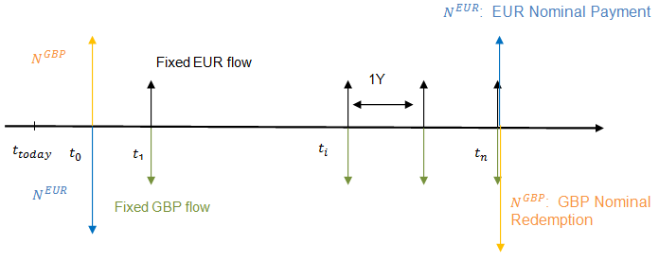

Figure : GBP-EUR Fixed-Fixed Xccy swap

### Net Present Value:

The NPV as priced in Murex pricer (e-tradepad) valued at **today’s Date** as the settlement delay follows the currency settlement delay. In this case, +0 open days for GBP. The NPV is calculated in GBP:

${NPV}_{GBP}^{Today}={NPV}_{GBP leg }^{Today}-{NPV}_{EUR leg }^{Today}*\frac{1}{{FX}_{Disc}^{GBP-EUR}}$

$${NPV}_{GBP leg }^{Today}=N^{GBP}*\left({DF}_{0}^{GBP Basis}-{DF}_{n}^{GBP Basis}\right)-\sum_{i=1}^{n}{\left[N^{GBP}*r^{GBP}{*∆}_{i}^{flow}*{DF}_{i}^{GBP Basis}\right]}$$

$${NPV}_{EUR leg }^{Today}=N^{EUR}*\left({DF}_{0}^{EUR Basis}-{DF}_{n}^{EUR Basis}\right)-\sum_{i=1}^{n}{\left[N^{EUR}*r^{EUR}{*∆}_{i}^{flow}*{DF}_{i}^{EUR Basis}\right]}$$

The notional $N^{EUR}$ is calculated using the FX spot agreed at trade inception

$$N^{EUR}= N^{GBP}* {FX}_{Trade}^{GBP-EUR}$$

Today’s NPV expressed in GBP is converted to USD using the discounted FX spot.

$${NPV}_{USD}^{Today}={NPV}_{GBP}^{Today}*{FX}_{Disc}^{GBP-USD}$$

### Zero IR delta:

* + - 1. EUR USD basis curve:
 $${DV01}_{Total}^{EUR Basis}={DV01}_{Disc}^{EUR Basis}+{DV01}_{{FX}_{spot}}^{EUR Basis}$$

 $${DV01}_{Disc}^{EUR Basis}=N^{EUR}*\left(∆_{0}^{EUR Basis}.{DF}_{0}^{EUR Basis}-{∆_{n}^{EUR Basis}.DF}_{n}^{EUR Basis}\right)-\sum_{i=1}^{n}{\left[N^{EUR}*r^{EUR}{*∆}_{i}^{flow}*{∆_{i}^{EUR Basis}.DF}_{i}^{EUR Basis}\right]}$$

 $${DV01}_{{FX}_{spot}}^{EUR Basis}={NPV}_{EUR leg }^{Today}*∆_{0}^{EUR Basis}$$

   2. GBP USD Basis curve:
 $${DV01}_{Total}^{GBP Basis}={DV01}_{Disc}^{GBP Basis}+{DV01}_{{FX}_{spot}}^{GBP Basis}$$

 $${DV01}_{Disc}^{GBP Basis}={-N}^{GBP}*\left(∆_{0}^{GBP Basis}.{DF}_{0}^{GBP Basis}-{∆_{n}^{GBP Basis}.DF}_{n}^{GBP Basis}\right)+\sum_{i=1}^{n}{\left[N^{GBP}*R^{GBP}{*∆}_{i}^{flow}*{∆_{i}^{GBP Basis}.DF}_{i}^{GBP Basis}\right]}$$

 $${DV01}_{{FX}_{spot}}^{GBP Basis}={NPV}_{GBP leg}^{Today}*∆_{0}^{GBP Basis}$$

   3. USD FedFund curve:

$${DV01}_{{FX}_{spot}}^{Fed}={DV01}_{{FX}_{spot}}^{Fed-EUR leg}+{DV01}_{{FX}_{spot}}^{Fed-GBP leg}$$

$${DV01}_{{FX}_{spot}}^{Fed-EUR leg}=-{NPV}_{EUR leg }^{Today}*{FX}_{Spot}^{EUR/USD}*∆_{0}^{Fed}*\frac{{DF}_{0}^{Fed}}{{DF}_{0}^{EUR Basis}}$$

$${DV01}_{{FX}_{spot}}^{Fed-GBP leg}=-{NPV}_{GBP leg }^{Today}*{FX}_{Spot}^{GBP/USD}*∆_{0}^{Fed}*\frac{{DF}_{0}^{Fed}}{{DF}_{0}^{GBP Basis}}$$

### FX delta:

As the collateralisation currency is different from the one used in the cross currency product. The FX delta is expressed against two FX spot (i.e. GBP-USD FX rate and EUR-USD FX rate)

${NPV}_{USD}^{spot}= {NPV}_{GBP leg }^{Spot}*{FX}_{Spot}^{GBP-USD}-{NPV}_{EUR leg }^{Spot}*{FX}_{Spot}^{EUR-USD}$

The FX delta is then:

$$\frac{∂{NPV}_{USD}^{Total}}{∂{FX}_{Spot}^{EUR/USD}}=-{NPV}_{EUR leg }^{Spot}=-N^{EUR}\left(1-\frac{{DF}_{n}^{ EUR Basis}}{{DF}_{0}^{EUR Basis}}\right)+\sum_{i=1}^{n}{\left[N^{EUR}*R^{EUR}{*∆}_{i}^{flow}*\frac{{DF}_{i}^{EUR Basis}}{{DF}_{0}^{EUR Basis}}\right]}$$

And

$$\frac{∂{NPV}_{USD}^{Total}}{∂{FX}_{Spot}^{GBP/USD}}={{NPV}_{GBP leg }^{Spot}=N}^{GBP}\left(1-\frac{{DF}_{n}^{GBP Basis}}{{DF}_{0}^{GBP Basis}}\right)-\sum_{i=1}^{n}{\left[N^{GBP}*R^{GBP}{*∆}_{i}^{flow}*\frac{{DF}_{n}^{GBP Basis}}{{DF}_{0}^{GBP Basis}}\right]}$$

## EUR-USD cross currency basis swap:

### Cash flows

A basis cross currency swap has the following flows:

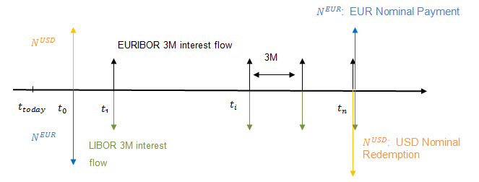

Figure : EUR-USD Xccy swap

### Net Present Value:

The NPV as priced in Murex pricer (e-tradepad) valued at **Spot Date** i.e. settlement date of the XCCS. In our case, +2 open days. The NPV is calculated in EUR:

${NPV}_{EUR}^{Spot}= {NPV}_{EUR leg }^{Spot}-{NPV}_{USD leg }^{Spot}*\frac{1}{{FX}_{Disc}^{EUR-USD}}$

$${NPV}_{EUR leg }^{Spot}=N^{EUR}\left(1-\frac{{DF}_{n}^{EUR Basis}}{{DF}_{0}^{EUR Basis}}\right)-\sum_{i=1}^{n}{\left[{N^{EUR}(F}_{i}^{EURIBOR 3M }+{Bs}_{EUR}){*∆}_{i}^{flow}*\frac{{DF}_{i}^{EUR Basis}}{{DF}_{0}^{EUR Basis}}\right]}$$

$${NPV}_{USD leg }^{Spot}=N^{USD}\left(1-\frac{{DF}_{n}^{Fed}}{{DF}_{0}^{Fed}}\right)-\sum_{i=1}^{n}{\left[N^{USD}* {(F}_{i}^{LIBOR 3M}+{Bs}_{USD}){*∆}_{i}^{flow}*\frac{{DF}_{i}^{Fed}}{{DF}_{0}^{Fed}}\right]}$$

The notional $N^{USD}$ is calculated using the FX spot agreed at trade inception

$$N^{USD}= N^{EUR}* {FX}_{Trade}^{EUR-USD}$$

Today’s NPV expressed in EUR is converted to USD using the discounted FX spot.

$${NPV}_{USD}^{Today}={NPV}_{EUR}^{Spot}*{DF}_{0}^{Basis}*{FX}_{Disc}^{EUR-USD}$$

The formula is $${NPV}_{USD}^{Today}={NPV}_{EUR}^{Spot}*{FX}_{Spot}^{EUR-USD}*{DF}_{0}^{Fed}$$

### Zero IR delta:

* + - 1. EUR USD basis curve
 $${DV01}_{Total}^{EUR Basis}={DV01}_{Disc}^{EUR Basis}+{DV01}_{{FX}_{spot}}^{EUR Basis}$$

 $${DV01}_{Disc}^{EUR Basis}={-N}^{EUR}*\left(∆_{0}^{EUR Basis}.{DF}_{0}^{EUR Basis}{-∆}_{n}^{EUR Basis}.{DF}_{n}^{EUR Basis}\right)+\sum_{i=1}^{n}{\left(N^{EUR}*{(\left(\frac{{DF}_{i-1}^{Euribor 3M}}{{DF}_{i}^{Euribor 3M}}-1\right)}/{∆_{i}^{fwd}}+{Bs}_{EUR}){*∆}_{i}^{flow}*∆_{i}^{EUR Basis}*{DF}_{i}^{EUR Basis}\right)}$$

 $${DV01}_{{FX}_{spot}}^{EUR Basis}={NPV}_{EUR leg}^{Today}*∆_{0}^{EUR Basis}$$

   2. EUR EURIBOR 3M curve
 $${DV01}_{Fwd}^{EUR EURIBOR 3M}=\sum_{i=1}^{n}{\left[N^{EUR}*{(∆}_{i-1}^{fwd}{-∆}_{i}^{fwd})*\frac{{DF}_{i-1}^{Euribor 3M}}{{DF}_{i}^{Euribor 3M}}*\frac{∆_{i}^{flow}}{∆_{i}^{fwd}}*{DF}_{i}^{EUR Basis}\right]}$$

     3. USD FedFund curve
 $${DV01}_{Total}^{Fed}={DV01}_{Disc}^{Fed}+{DV01}_{{FX}_{spot}}^{Fed}$$

 $${DV01}_{Disc}^{Fed}=N^{USD}\left({{∆_{0}^{Fed}*DF}_{0}^{Fed}-∆}_{n}^{Fed}{*DF}_{n}^{Fed}\right)-\sum_{i=1}^{n}{\left[N^{USD}*\left({\left(\frac{{DF}_{i-1}^{USD Libor}}{{DF}_{i}^{USD Libor}}-1\right)}/{∆_{i}^{fwd}}+{Bs}_{USD}\right){*∆}_{i}^{flow}*∆_{i}^{Fed}*{DF}_{i}^{Fed}\right]}$$

 $${DV01}_{{FX}_{spot}}^{Fedfund}=-{NPV}_{EUR leg}^{Spot}*{FX}_{Spot}^{EUR/USD}*∆_{0}^{Fed}*\frac{{DF}_{0}^{Fed}}{{DF}_{0}^{Basis}}$$

   4. USD LIBOR 3M curve

$${DV01}_{Fwd}^{USD LIBOR 3M}=-\sum_{i=1}^{n}{\left[N^{USD}*{(∆}_{i-1}^{USD Libor}-∆_{i}^{USD libor})*\frac{{DF}_{i-1}^{USD Libor}}{{DF}_{i}^{USD Libor}}*{∆_{i}^{flow}}/{∆_{i}^{fwd}}*{DF}_{i}^{Fed}\right]}$$

### FX delta:

${NPV}_{USD}^{Spot}= {NPV}_{EUR leg}^{Spot}*{FX}_{Spot}^{EUR/USD}-{NPV}_{USD leg}^{Spot}$

$$\frac{∂{NPV}_{USD}^{Spot}}{∂{FX}_{Spot}^{EUR/USD}}={NPV}_{EUR leg}^{Spot}=N^{EUR}\left(1-\frac{{DF}_{n}^{EUR Basis}}{{DF}_{0}^{EUR Basis}}\right)-\sum_{i=1}^{n}{\left[{N^{EUR}(F}_{i}^{EURIBOR 3M }+{Bs}_{EUR}){*∆}_{i}^{flow}*\frac{{DF}_{i}^{EUR Basis}}{{DF}_{0}^{EUR Basis}}\right]}$$

## EUR-USD resettable cross currency basis swap:

### Cash flows

EUR-USD resettable basis cross currency swap has the following flows:

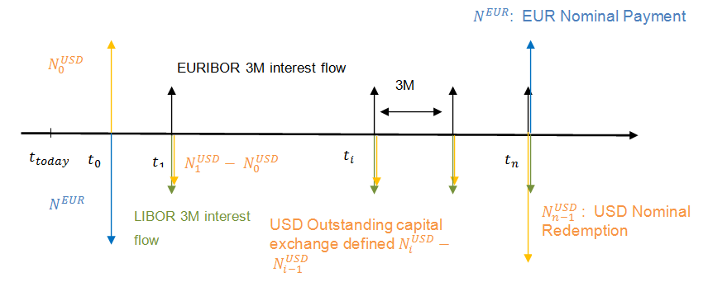

Figure : Resettable EUR-USD Xccy swap

### Net Present Value:

The NPV as priced in Murex pricer (e-tradepade) valued at **Spot Date** (ie settlement date of the XCCS. In this case, +2 open days. The NPV is calculated in EUR:

${NPV}_{EUR}^{Spot}= {NPV}_{EUR leg}^{Spot}-{NPV}_{USD leg }^{Spot}*\frac{1}{{FX}_{Spot}^{EUR-USD}}$

$${NPV}_{EUR leg}^{Spot}=N^{EUR}\left(1-\frac{{DF}_{n}^{EUR Basis}}{{DF}_{0}^{EUR Basis}}\right)-\sum_{i=1}^{n}{\left[{N^{EUR}(F}_{i}^{EURIBOR 3M }+{Bs}_{EUR}){*∆}_{i}^{fwd}*\frac{{DF}_{i}^{EUR Basis}}{{DF}_{0}^{EUR Basis}}\right]}$$

$${NPV}_{USD leg }^{Spot}=\left(N_{0}^{USD}-N_{n-1}^{USD}*\frac{{DF}_{n}^{Fed}}{{DF}_{0}^{Fed}}\right)-\sum_{i=1}^{n}{\left[N_{i-1}^{USD}* F_{i}^{LIBOR 3M}{*∆}_{i}^{fwd}*\frac{{DF}_{i}^{Fed}}{{DF}_{0}^{Fed}}\right]}+\sum_{i=1}^{n-1}{\left[{(N}_{i}^{USD}-N_{i-1}^{USD})*\frac{{DF}_{i}^{Fed}}{{DF}_{0}^{Fed}}\right]}$$

The notional $N_{i}^{USD}$ is calculated using the FX forward calculation using EUR – USD Basis curve and USD FedFund curve (for i>0). It is calculated from Forward cash flow date to spot date:

$$N_{i}^{USD}= N^{EUR}* {FX}_{{Fwd}_{i}}^{EUR-USD}$$

Today’s NPV expressed in EUR is converted to USD using the discounted FX spot.

$${NPV}_{USD}^{Today}={NPV}_{EUR}^{Spot}*{FX}_{spot}^{EUR-USD}*{DF}_{0}^{Fed}$$

### Zero IR delta:

* + - 1. EUR USD Basis curve:

With

* + - 1. EUR EURIBOR 3M:
 $${DV01}_{Fwd}^{EUR EURIBOR 3M}=\sum_{i=1}^{n}{N^{EUR}*\frac{{DF}_{i-1}^{Euribor}}{{DF}_{i}^{Euribor}}*\left(∆_{i}^{Euribor}{-∆}_{i-1}^{Euribor}\right)*{DF}_{i}^{Basis}}$$

     2. USD Fedfund:
 $${DV01}_{Total}^{Fedfund}={DV01}_{Disc}^{Fedfund}+{DV01}_{FXFwd}^{Fedfund}$$

 $${DV01}_{Disc}^{Fedfund}={DV01}_{Disc Outstanding capital}^{Fedfund}+{DV01}_{Disc Interest flow}^{Fedfund}$$

 $${DV01}_{Disc Outstanding capital}^{Fedfund}=\sum_{i=1}^{n-1}{\left({(N}_{i}^{USD}-N_{i-1}^{USD})*∆_{i}^{Fed}*{DF}_{i}^{Fed}\right)}+(N_{0}^{USD}*∆_{0}^{Fed}*{DF}_{0}^{Fed}-N_{n-1}^{USD}*∆_{n}^{Fed}*{DF}_{n}^{Fed})$$

 $${DV01}_{Disc Interest flow}^{Fedfund}=-\sum_{i=1}^{n}{ \left(N_{i-1}^{USD}\left(\frac{{DF}_{i-1}^{Libor}}{{DF}_{i}^{Libor}}-1\right)*{DF}_{i}^{Fed}*∆_{i}^{Fed}\right)}$$

 $${DV01}_{FXFwd}^{Fedfund}={DV01}_{FXFwd Outstanding capital}^{Fedfund}+{DV01}_{FXFwd Interest flow}^{Fedfund}$$

 $${DV01}_{FXFwd Outstanding capital}^{Fedfund}=-\sum_{i=1}^{n-1}{\left((N_{i}^{USD}*∆_{i}^{Fed}-N_{i-1}^{USD}*∆_{i-1}^{Fed})*{DF}_{i}^{Fed}\right)-\sum_{i=1}^{n-1}{\left({(N}_{i}^{USD}-N_{i-1}^{USD}){*DF}_{i}^{Fed})*∆_{0}^{Fed}\right)}}+\left(N_{n-1}^{USD}*{∆_{n-1}^{Fed}*DF}_{n}^{Fed}\right)-\left(N_{n-1}^{USD}*∆_{0}^{Fed}{*DF}_{n}^{Fed}\right)$$

$${DV01}_{FXFwd Interest flow}^{Fedfund}=\sum_{i=1}^{n}{ \left(N_{i-1}^{USD}*\left(\frac{{DF}_{i-1}^{Libor}}{{DF}_{i}^{Libor}}-1\right)*{DF}_{i}^{Fed}*∆_{i-1}^{Fed}\right)-\sum_{i=1}^{n}{ \left(N_{i-1}^{USD}*\left(\frac{{DF}_{i-1}^{Libor}}{{DF}_{i}^{Libor}}-1\right)*{DF}_{i}^{Fed}*∆_{0}^{Fed}\right)}}$$

3. USD LIBOR 3M:

$${DV01}_{Fwd}^{USD LIBOR 3M}=\sum_{i=1}^{n}{ \left(N_{i-1}^{USD}*\frac{{DF}_{i-1}^{Libor}}{{DF}_{i}^{Libor}}*{DF}_{i}^{Fed}*(∆_{i}^{Libor}{-∆}_{i-1}^{Libor})\right)}$$

### FX delta:

We start calculating the NPV XCCS in USD as of Spot date and we look for the FX delta against USD

${NPV}_{USD}^{Total}=\left(N^{EUR}*\left(1-\frac{{DF}_{i}^{EUR Basis}}{{DF}_{0}^{EUR Basis}}\right)-\sum_{i=1}^{n}{\left[{N^{EUR}*(F}_{i}^{EUR-3M }+Bs){*∆}_{i}^{fwd}*\frac{{DF}_{i}^{EUR Basis}}{{DF}_{0}^{EUR Basis}}\right]}\right)*{FX}_{spot}^{EUR-USD} +\left[\sum_{i=1}^{n}{ \left(N^{EUR}*{FX}_{spot}^{EUR-USD}*\frac{{DF}_{i-1}^{EUR Basis}}{{DF}_{i-1}^{Fed}}*\frac{{DF}_{0}^{Fed}}{{DF}_{0}^{Basis}}*F_{i}^{USD-3M }*∆_{i}^{fwd}*\frac{{DF}_{i}^{Fed}}{{DF}_{0}^{Fed}}\right)-\sum_{i=1}^{n-1}{\left(N^{EUR}*{FX}_{spot}^{EUR-USD}*\left( \frac{{DF}_{i}^{EUR Basis}}{{DF}_{i}^{Fed}}-\frac{{DF}_{i-1}^{EUR Basis}}{{DF}_{i-1}^{Fed}}\right)*\frac{{DF}_{0}^{Fed}}{{DF}_{0}^{Basis}}*\frac{{DF}_{i}^{Fed}}{{DF}_{0}^{Fed}}\right)+\left(N^{EUR}*{FX}_{spot}^{EUR-USD}*\frac{{DF}_{n-1}^{EUR Basis}}{{DF}_{n-1}^{Fed}}*\frac{{DF}_{n}^{Fed}}{{DF}_{0}^{Fed}}-N_{0}^{USD}\right)}}\right]$

**Already Fixed**

The FX delta is then (i starts from 2 to take into account that initial flows are already fixed):

$$\frac{∂{NPV}_{USD}^{Total}}{∂Sp}=\left(N^{EUR}*\left(1-\frac{{DF}_{i}^{EUR Basis}}{{DF}_{0}^{EUR Basis}}\right)-\sum_{i=1}^{n}{\left[{N^{EUR}*(F}_{i}^{EUR-3M }+Bs){*∆}_{i}^{fwd}*\frac{{DF}_{i}^{EUR Basis}}{{DF}_{0}^{EUR Basis}}\right]}\right)+\sum_{i=2}^{n}{ \left(N^{EUR}*\frac{{DF}_{i-1}^{EUR Basis}}{{DF}_{i-1}^{Fed}}*\frac{{DF}_{0}^{Fed}}{{DF}_{0}^{Basis}}*F_{i}^{USD-3M }*∆_{i}^{fwd}*\frac{{DF}_{i}^{Fed}}{{DF}_{0}^{Fed}}\right)+\left(N^{EUR}*\frac{{DF}_{n-1}^{EUR Basis}}{{DF}_{n-1}^{Fed}}*\frac{{DF}_{n}^{Fed}}{{DF}_{0}^{Fed}}\right)-\sum_{i=2}^{n-1}{\left(N^{EUR}*\left( \frac{{DF}_{i}^{EUR Basis}}{{DF}_{i}^{Fed}}-\frac{{DF}_{i-1}^{EUR Basis}}{{DF}_{i-1}^{Fed}}\right)*\frac{{DF}_{0}^{Fed}}{{DF}_{0}^{EUR Basis}}*\frac{{DF}_{i}^{Fed}}{{DF}_{0}^{Fed}}\right)}}$$

# MX reconciliation:

Pricing and risks for the different cross currency basis swap is proven in the following paragraphs.

## GBP-EUR Fixed-Fixed cross currency basis swap:

### Trade definition

The trade is priced considering its first cash flow (Nominal Exchange) starts at spot date.

The fixed rate on the EUR leg is 1.5% and the one on the GBP LEG is 1%.

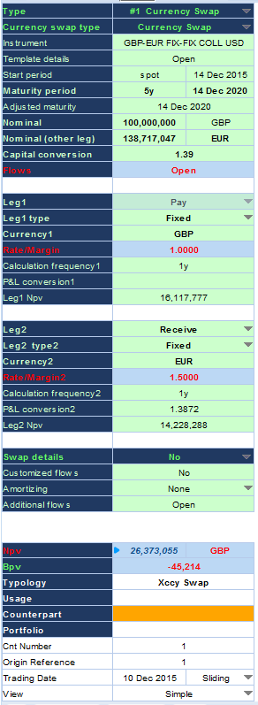

Figure : GBP-EUR Fixed Fixed Xccy trade definition

The system Date is **10/12/2015** and the start date for the FX rate is **14/12/2015**.

### NPV:

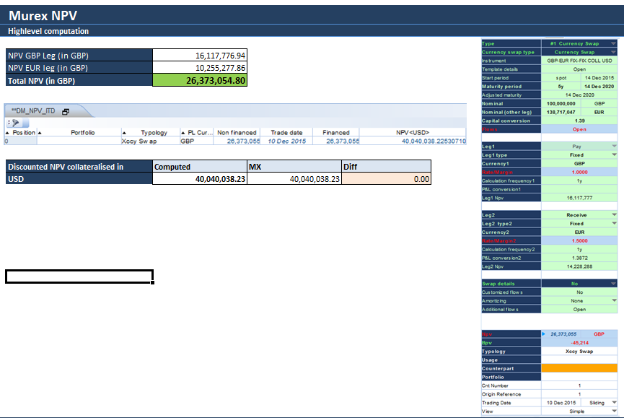

Figure : GBP-EUR Fixed Fixed Xccy NPV matching results

### IR delta discount GBP leg:

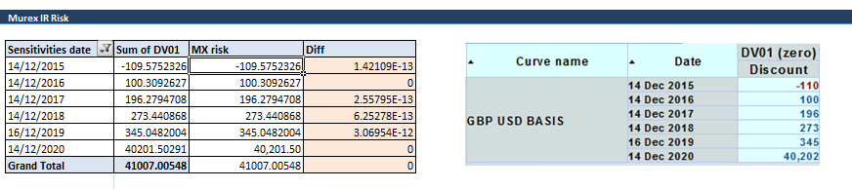

Figure :GBP-EUR Fixed Fixed Xccy IR delta discount GBP leg matching results

### IR delta discount EUR leg:

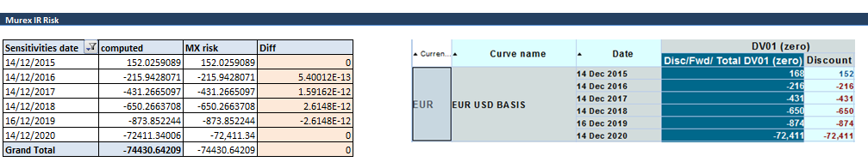

Figure : GBP-EUR Fixed Fixed Xccy IR delta discount EUR leg matching results

### FX spot conversion IR risk-GBP leg:

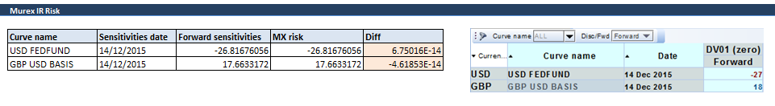

Figure : GBP-EUR Fixed Fixed Xccy FX spot conversion IR risk-GBP leg matching results

### FX spot conversion IR risk-EUR leg:

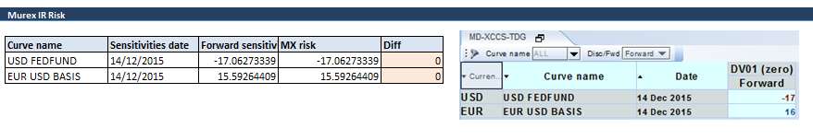

Figure : GBP-EUR Fixed Fixed Xccy FX spot conversion IR risk-EUR leg matching results

### FX delta:

More details about those results described in section 6.2.2

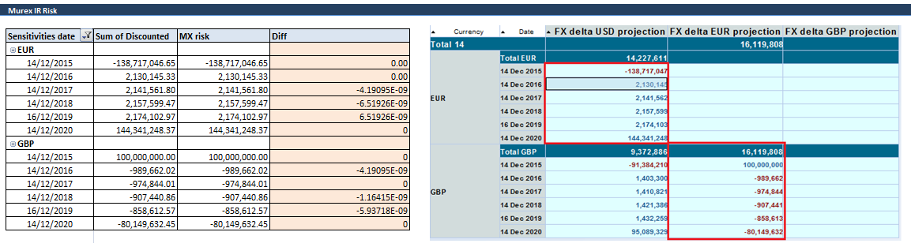

Figure : GBP-EUR Fixed Fixed Xccy FX delta matching results;

## EUR-USD cross currency basis swap:

### Trade definition

The trade is priced considering its first cash flow (Nominal Exchange) starts at spot date.

The spread on EUR floating leg is -0.1 and on USD floating leg is 0.4

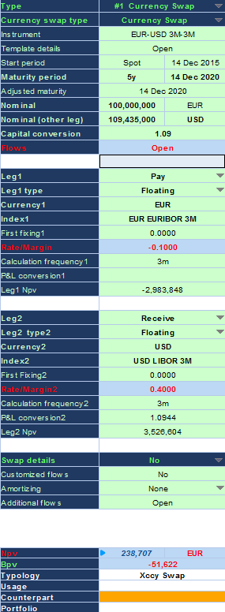

Figure : EUR-USD Xccy trade definition

The system Date is **10/12/2015** and the first spot date for the FX rate is **14/12/2015**.

### NPV:

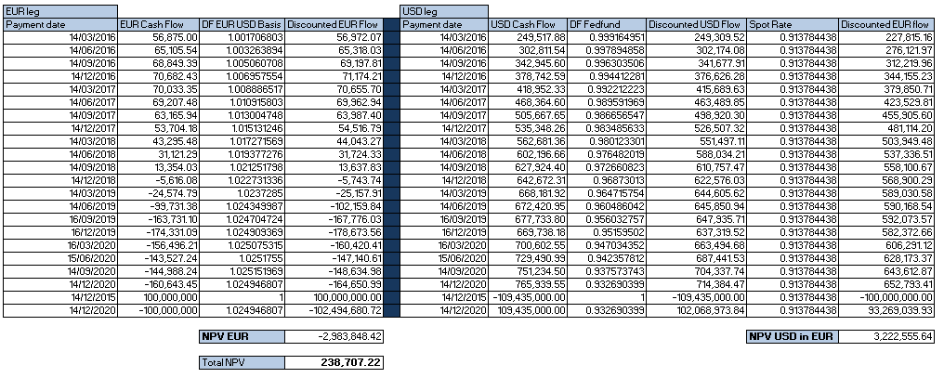

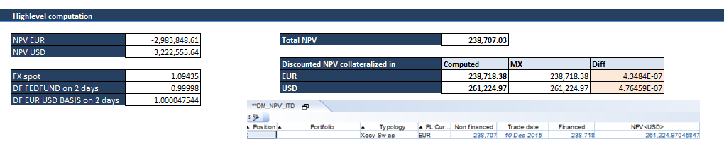

Figure : EUR-USD Xccy NPV matching results

### Total zero IR deltas:

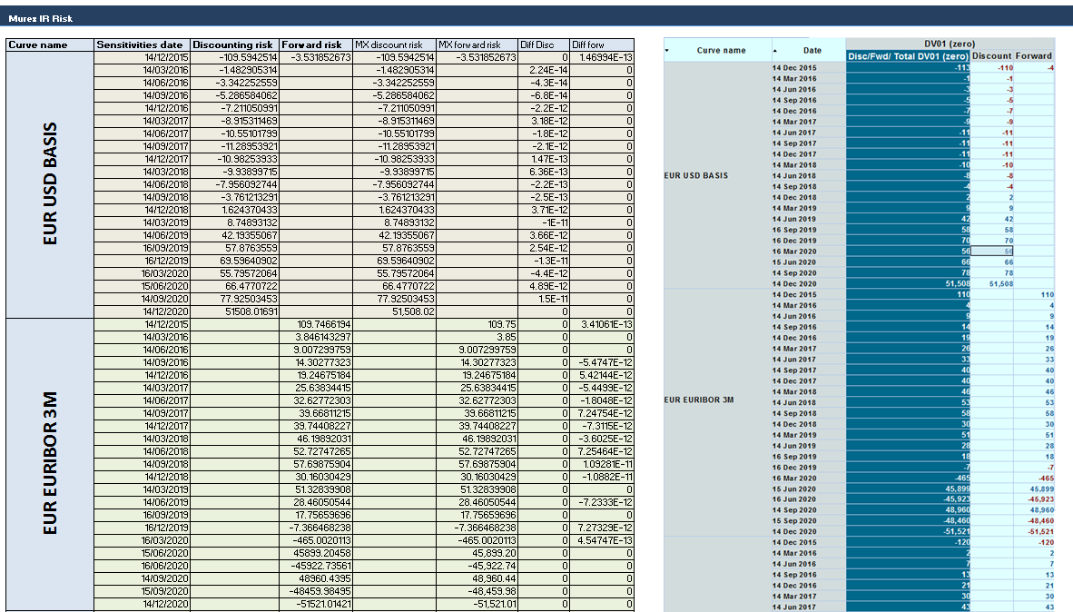

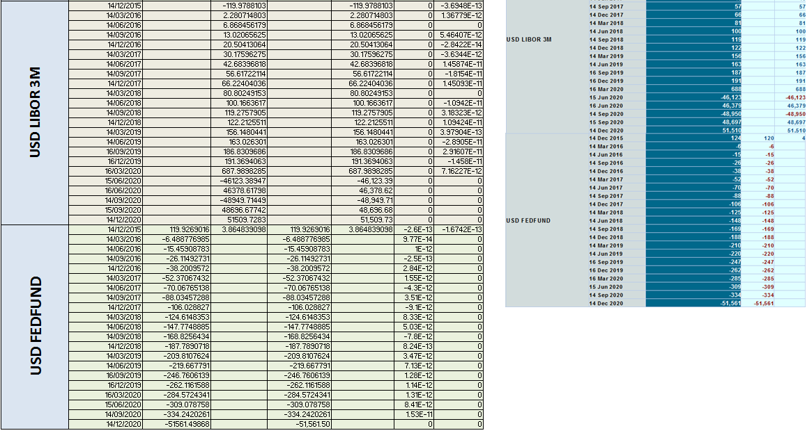

Figure : EUR-USD Xccy IR delta matching results

### FX spot conversion IR risk:

### 

Figure : EUR-USD Xccy FX spot conversion IR risk matching results

### FX delta:

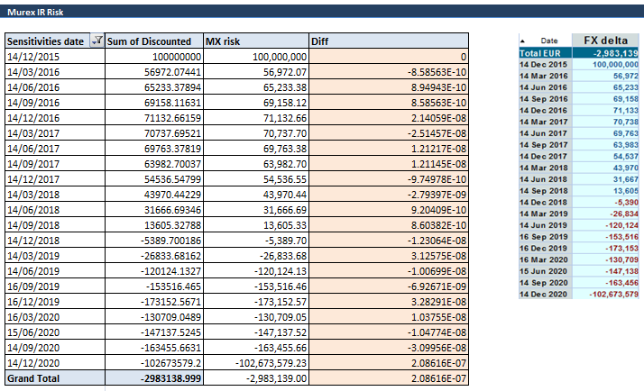

Figure : EUR-USD Xccy FX delta matching results

Figure : Total IR Risk

## Resettable cross currency basis swap

### Trade definition

The trade is priced considering its first cash flow (Nominal Exchange) starts at spot date.

The spread on EUR floating leg is -0.1 and on USD floating leg is 0.4

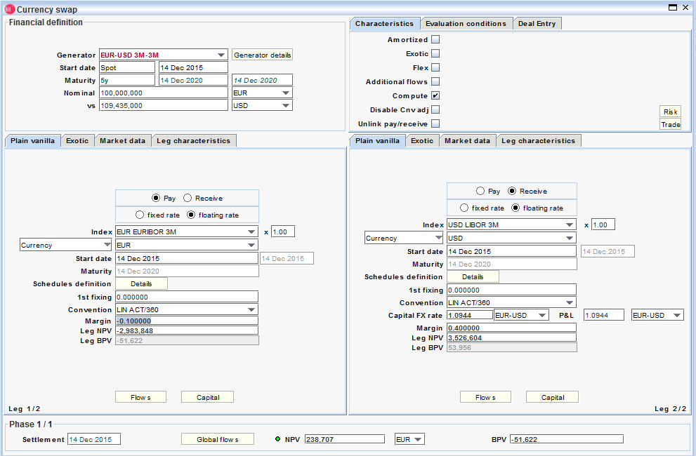

Figure : Resettable EUR-USD Xccy trade definition

The system Date is **10/12/2015** and the first spot date for the FX rate is **14/12/2015**.

### Total zero IR deltas:

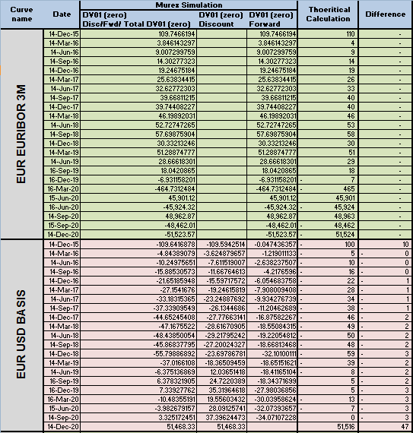

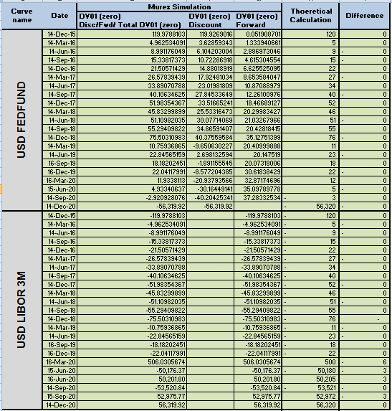

Figure : Resettable EUR-USD Xccy IR delta matching results

### FX delta:

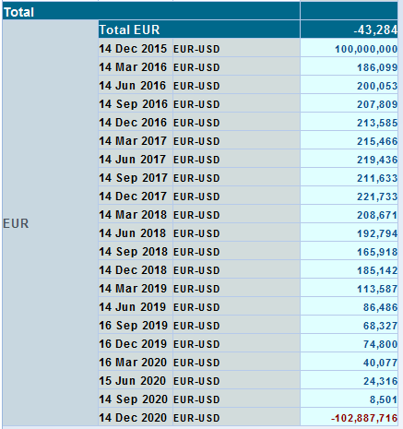

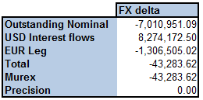

Figure : Resettable EUR-USD Xccy FX delta matching results

## EUR-USD resettable cross currency basis swap: NPV and Risk Post trade inception

### At the FX Reset Date

5Y resettable cross currency basis swap with 4Y remaining to trade’s expiry is priced in this exercise. The FX reset date is 10/12/16 in the current example. XCCS is priced before and after an FX fixing event and the risk behaviour will be checked.

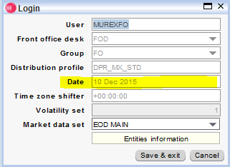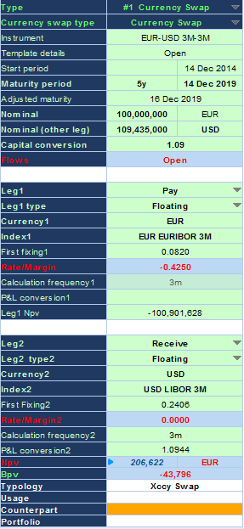

Figure : Resettable EUR-USD Xccy Trade definition

### Before FX fixing

* Fx delta from EUR Leg will be the NPV of the leg valued at spot date in EUR

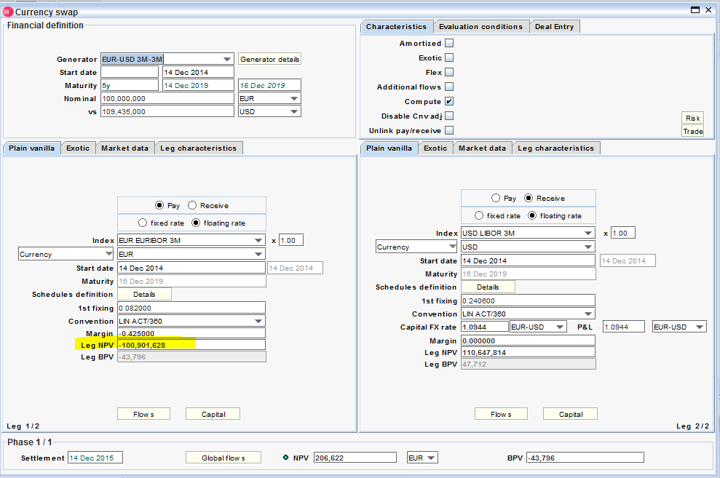

Figure : FX delta coming from EUR leg before FX fixing

* Fx delta of USD interest flows is the discounted flows at spot date converted to EUR using Fx spot rate

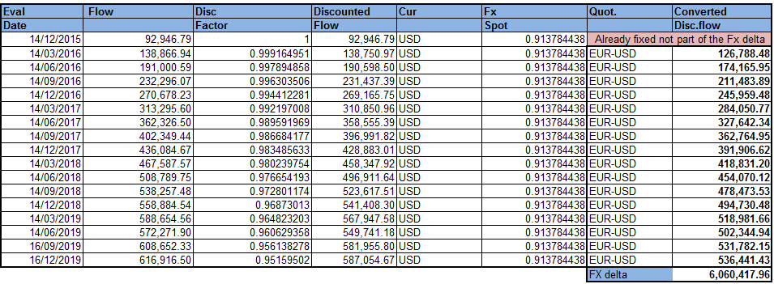

Figure : FX delta of USD interest flows before FX fixing

* Fx delta of USD outstanding capital is detailed below:

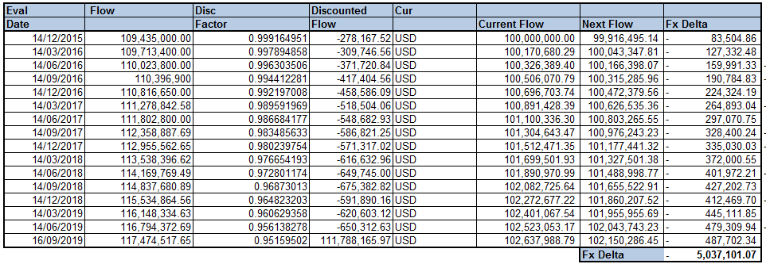

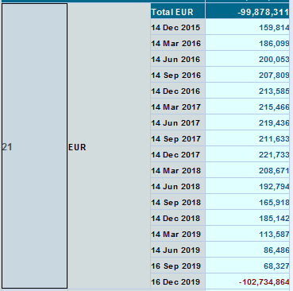Figure : FX delta of USD outstanding capital before FX fixing

The total FX delta is still valid:

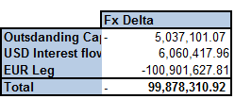

Figure : Total FX delta before FX fixing

### After an FX fixing

The EUR leg contribution will remain the same; however, we will remove the 14th December 2015 flows contributions from the USD leg contribution:

* USD interest flows

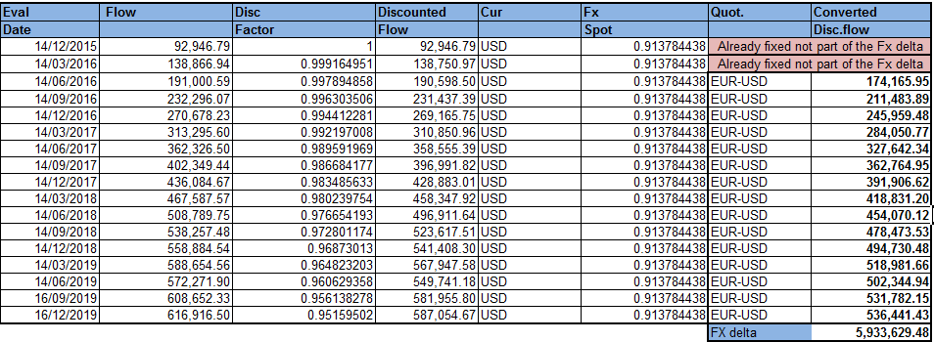

Figure : FX delta of USD interest flow after FX fixing

* Outstanding notional

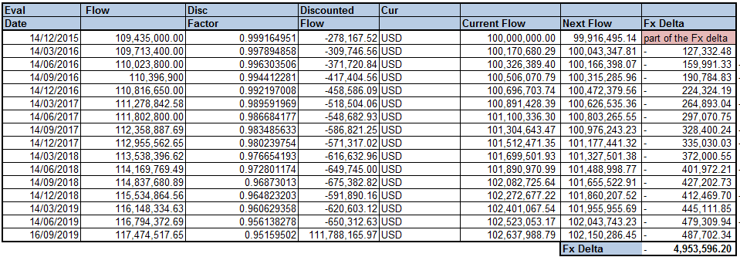

Figure : FX delta of USD outstanding capital after FX fixing

This is in line with Murex:

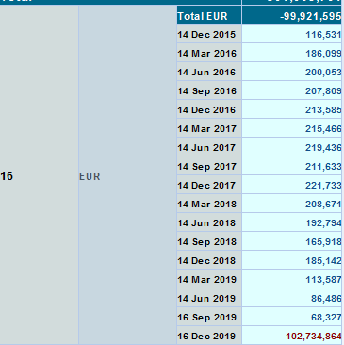

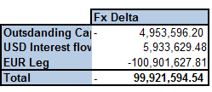

Figure : Total FX delta after FX fixing

### After an FX reset FX Date (2 days after the Notional exchange)

In this test case, 2 years resettable cross currency basis swap post first notional exchange is priced. The pricing date remains 10/12/16 and the first exchange nominal is 09/12/16 (past date). The deal’s flows is as following

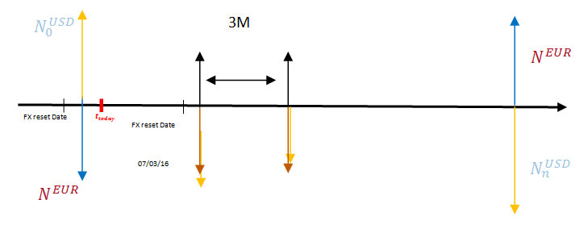

Figure : Cash flows representation after FX reset date

The deal ticket is as following:

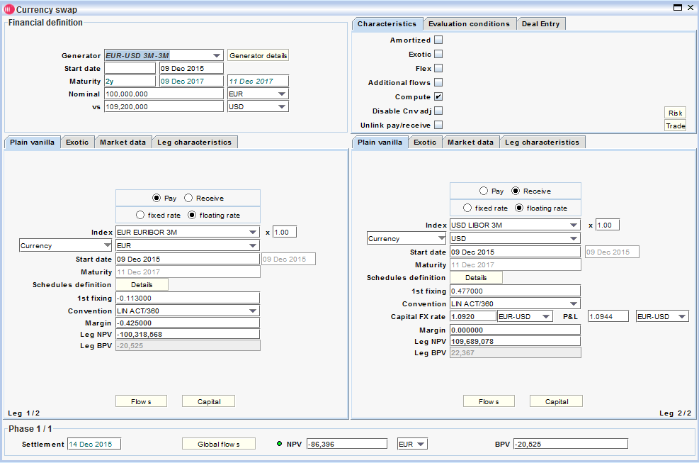

Figure : Deal ticket

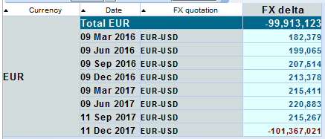Thus the FX delta is very high and the main contribution is from the EUR leg.

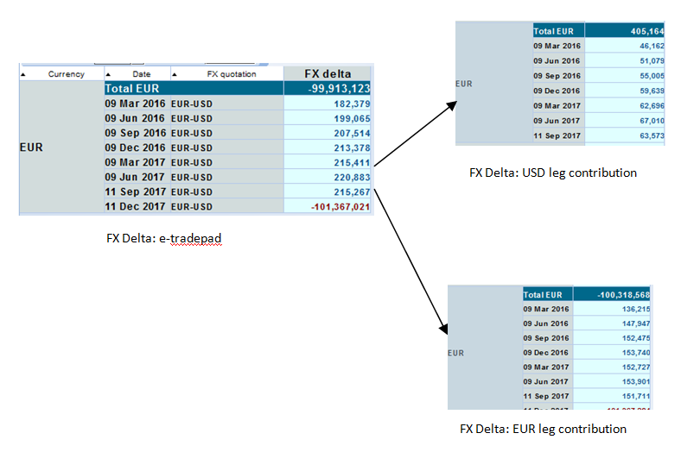

Figure : FX delta contribution after FX reset date

# Required MX configuration:

Several MX settings are required in order for Murex to reconcile the theoretical formulas in the current Murex version (v3.1.27), below main necessary configuration are listed:

## Basis curve as an outright curve:

As previously said Basis curves are outright curves and are not configured as spread on another curve. They calibrate zero coupons curve directly from its instruments. The “calibration” setting is hence set to “curve assignments”

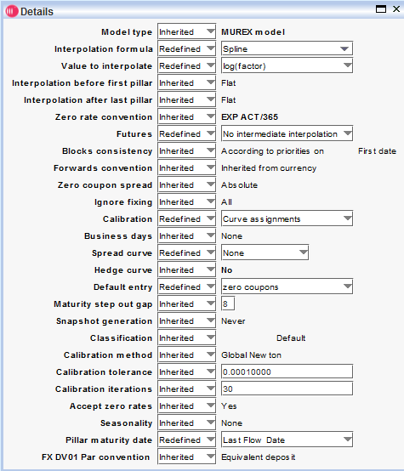

Figure : Basis curve settings

## FX cross sensitivities

FX cross sensitivities across currencies in the basis curve could be triggered via a “default entry” setting at the curve level:

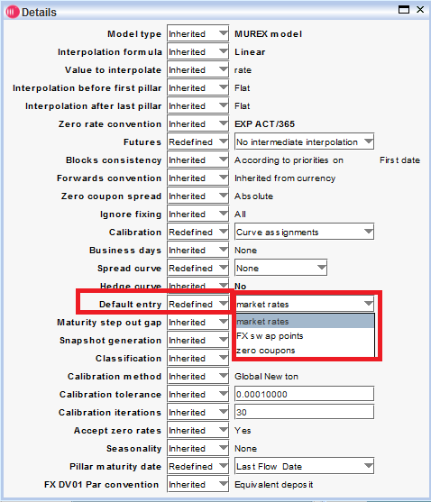

Figure : Default entry curve specific setting

The setting if set to “zero coupons” disables cross sensitivities. If it is set to “market rate” then the cross sensitivities will be calculated with respect to “keep market quotes constant” scenarios.

Generally speaking, the cross sensitivities will be defined as following:

$DV{01}_{Cross A}^{Curve B}={\left(\frac{∂NPV}{∂ZC_{i}^{Curve B} }\right)}_{i=1..k}$ = ${\left(\frac{∂ZC_{i}^{Curve A}}{∂ZC_{j}^{Curve B} }\right)}_{j=1..k, i=1..n}{\left(\frac{∂NPV}{∂ZC_{i}^{Curve A} }\right)}_{i=1..n}$

This sensitivity will capture the recalibration effect of two dependent curves. In the EUR-USD resettable cross currency basis swap case, Murex will calculate the recalibration effects of USD Libor 3M and USD FedFund on the basis curve if the FX cross sensitivity calculation is activated. This is not in line with interest rate risk expected results

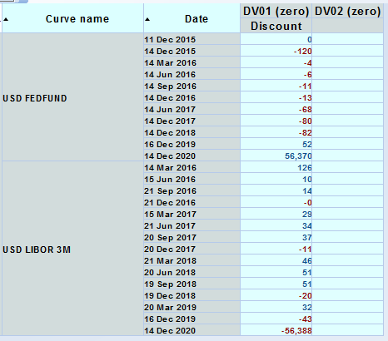

Figure : DV01 discounting risk projected on USD libor 3M due to cross senstivities

**FX cross sensitivities** should hence **not be triggered** and the setting **“default entry”** should be set to **“zero coupons”** in order to disable cross sensitivities computation.

## Rate/Rate propagation

The setting used in the default mode in Rate propagation.

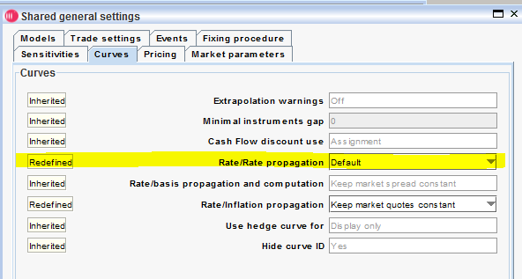

Figure : Rate/Rate propagation setting

This means there is no cross effect calculated in delta (recalibration effect due to dual calls in curves). This was proven in the previous paragraphs.

As a reminder Murex proposes 3 propagation modes (used applied scenarios to the curves). These modes drive the recalibration of curves when a scenario is applied directly on the curve. It has also an impact of the delta calculation:

* Propagate zero coupon shifts (Default mode in v27 in LCH implementation): the zero coupon shift on a target curve will be applied on all curves of the same currency.
* Keep market quotes constant: When a curve is shifted, market quotes of other curves remain constant (a spread is computed at the level of the shifted curve to prevent other curves calibrating on the same tenors / instruments).
* Keep zero coupons constant: When a curve is shifted, zero coupons of dependent curves remain constant.

## FX router and FX curve assignments:

The FX index used in the XCCS is following the FX router assignments:

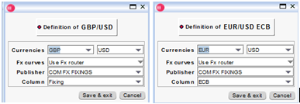

Figure : FX routers definition

The FX curves assignment:

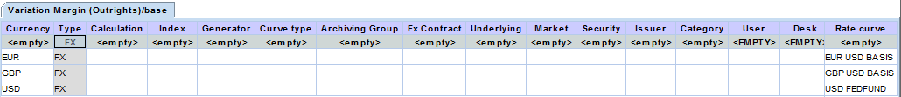

Figure : FX curves assignment

## FX conversion settings:

Two settings are needed in order to be able to convert today’s NPV from one currency to another using the discounted FX spot at the simulation level:

* “Spot conversion” flag set to “discounted” in FX general settings:

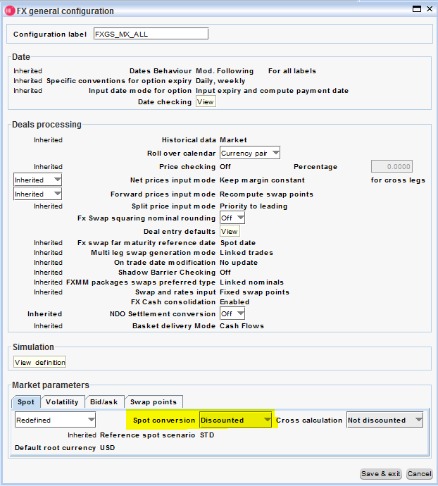

Figure : General FX setting of Spot conversion

* “FX spot conversion” set to “discounted” in the simulation setup screen:

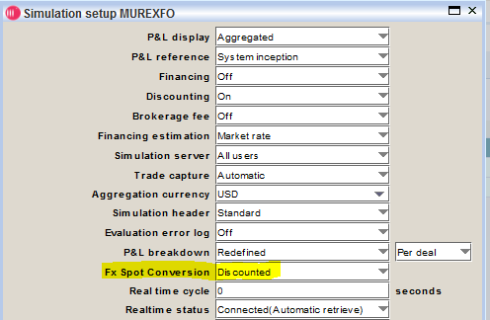

Figure : Simulation setting of FX spot conversion

Note that those settings do not impact the current official VM for current cleared Swapclear products. The FX conversion from local currency to GBP used to express the official figures of IM and VM is done outside of MX.3 pricing engine and is using the BAU risk validated FX spot rate.

It is worth to mention that for an accurate calculation, Risk change recommends using discounted FX spot instead of the FX Spot when calculating the VM and IM for members.

Finally, this means that a new workflow based on a “Simulation FX discounted spot conversion” might be necessary for cross currency basis swaps.

## FX delta- Simulation viewer output configuration

There is the possibility to define which currency is the non risky one. The FX delta will capture any NPV difference for any **FX spot** movement with respect to the non risky one. This is possible by setting the Family i.e. the leading currency to calculate the FX delta against:

The non risky currency is USD in the POC as cross currency basis swaps are collateralised in USD.

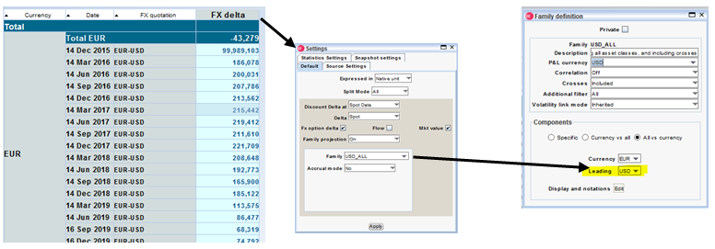

Figure : FX delta- Simulation viewer output configuration

There are two configurations in the simulation viewer to calculate the FX Delta. A daily PL selldown is supposed to take place or not depending on the “flow” setting in the simulation view:

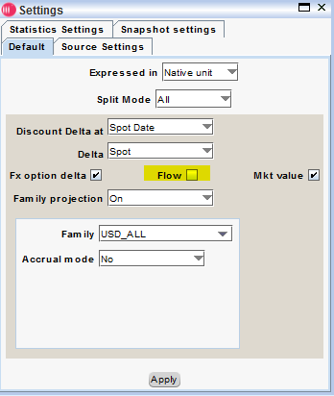

Figure : "Flow" setting

If flow setting is ticked, there is no PL selldown and thus the past cash flow in risky currency will be calculated in the FX delta (The cash flow is capitalised to today date).

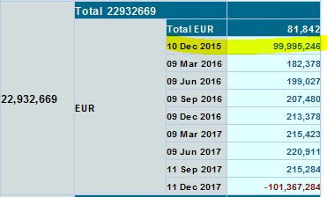

Figure : Past Cash is counted in FX delta

If the flag is un-ticked, then the FX delta will consider only MV in the calculation:

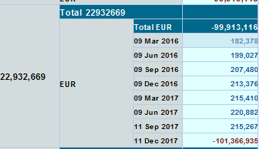

Figure : Only MV is considered in FX delta

The setting **“Flow”** box has to be **unselected** in the FX delta settings in order for the past cash not to contribute to FX delta.

# Gaps/ unexpected behaviours:

This section describes:

* Gaps found during the POC and confirmed by Murex support team.
* Unexpected behaviours found in Murex. LCH is waiting for an explanation from Murex (Configuration changes, workaround proposal, bug confirmation etc...)

## Gaps:

### “EUR: STD” curve:

“EUR: STD” curve appears in the “pop-up market data” even if it should not. This issue is considered by Murex as a bug and they confirmed that it is solved in higher version (V3.1.36). However, it is a non-issue as it is only a display issue; there are no side effects on curve calibration, product pricing or risk calculation. More detail in MX case **604023**.

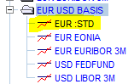

Figure : Basis Curve - Wrong Dependency

### Basis’s curve Jacobean Matrix wrongly computed:

PAR interest rate risk is retrieved based on zero interest rate risk and basis curve’s Jacobean matrix following the below formula:

$${[DV01]}_{PAR}^{curve}={[DV01]}^{curve}×{[\frac{dZ}{dR}]}^{curve}$$

However, the figures of the Jacobean matrix are not as expected and unexplained. Depending on the basis curve constitution, the matrix Jacobean is weird, instable or wrong.

Murex has confirmed that there is a bug in v27 when a rate curve contains Swap points as pillars.

MX case **608605** has been raised to follow-up on this point.

The correction was provided in the patch 3.1.27.16.en.10. (See section 7.3 describing the validation of the fix)

## Unexpected behaviours:

### USD projected FX delta for GBP-EUR cross currency swap:

Expected FX deltas have been reconciled but expressed in the wrong outputs. Getting FX risk on different outputs should be taking into account when building the risk report in SwapAgent project. This will nullify the issue; however, MX case **614828** has been raised asking Murex for support.

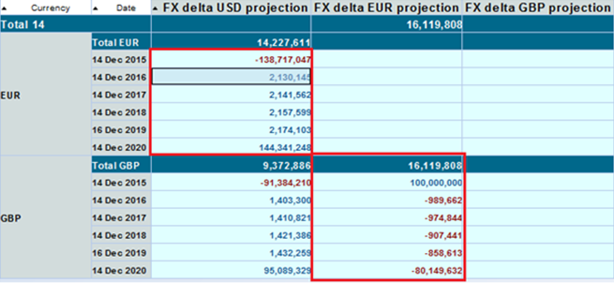

Figure : FX delta projected in two different outputs

### PL currency change not persistent at trade level:

It is not possible to express the PL Currency of a cross currency basis swap trade in a different currency than the base currency of the currency quotation (e.g. EUR is the base currency of EUR-USD currency quotation).

The only analytical figure impact spotted by this limitation at this stage is a mismatch between the expected FX spot conversion IR risk and the default Murex result. This mismatch can be ignored as it is very small.

MX case **616211** has been raised asking Murex for support.

# Patch 3.1.27.16.en.10 and corrections:

Murex provided the patch 3.1.27.16.en.10 that contains two major corrections for:

* Xccy basis curve jacobian and PV01 (6.1.2)
* Cross sensitivities in the simulation DV01 and PV01

The aim of section 7 is to not only to test the fixes but as well rerunning all the testing done previously in version 3.1.27.16.en.7 to verify that there is no regression.

Please note that the same Murex test environment has been used for the entire POC and was upgraded from version 3.1.27.16.en.7 to version 3.1.27.16.en.10.

## Settings and configuration

In addition to the required configuration listed in section 5, the below one are needed as well:

### Curves default entry setting

Any cross currency basis curve must have the setting “default entry” set to *market rates*:

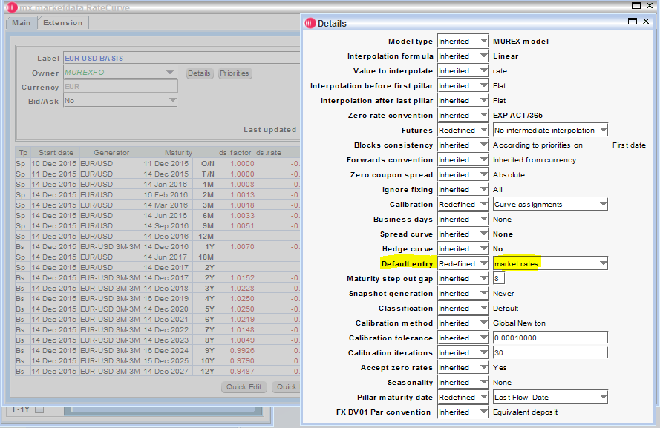

Figure : Default entry setting

### Slash /XCCY_SENSIS_FOLLOW_PROPAGATION:

The slash **/XCCY_SENSIS_FOLLOW_PROPAGATION:** is required in order to remove the not required cross sensitivity in the simulation risk figures for both DV01 and PV01.

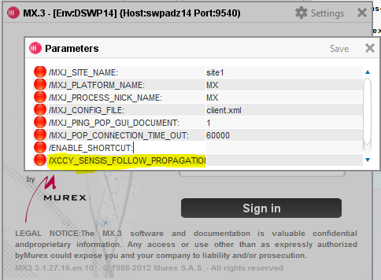

Figure : Slash /XCCY_SENSIS_FOLLOW_PROPAGATION:

### “FX indexation evaluate using” setting:

The “FX indexation evaluate using” needs to be set to Quoted spot in order to have the fx forward used on the Xccy swap resettable leg calculated between spot date and forward shifter defined in the currency pair.

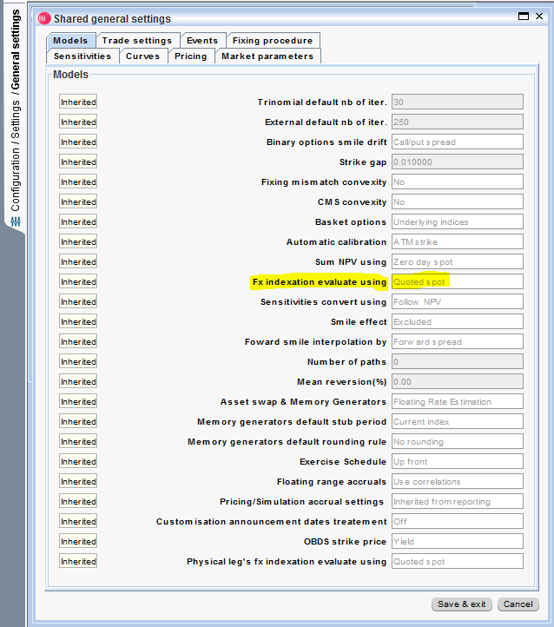

Figure : FX indexation evaluate using setting

FX indexation evaluate using:

* Quoted spot

The FX forward rate will be computed using the discount factors between spot date and fixing date + forward shifter defined in the currency pair.

* Zero-day spot

The FX forward rate will be computed using the discount factors between spot date and fixing date (no delay).

* Follow NPV

The FX forward rate will be computed using the discount factors between spot date and fixing date + forward shifter defined in the trade. Not recommended.

## Cross currency basis curve calibration

The curve EUR USD basis was kept the same and the calibrated zc with the new version- 3.1.27.16.en.10 -were compared with the previous obtained within 3.1.27.16.en.7.

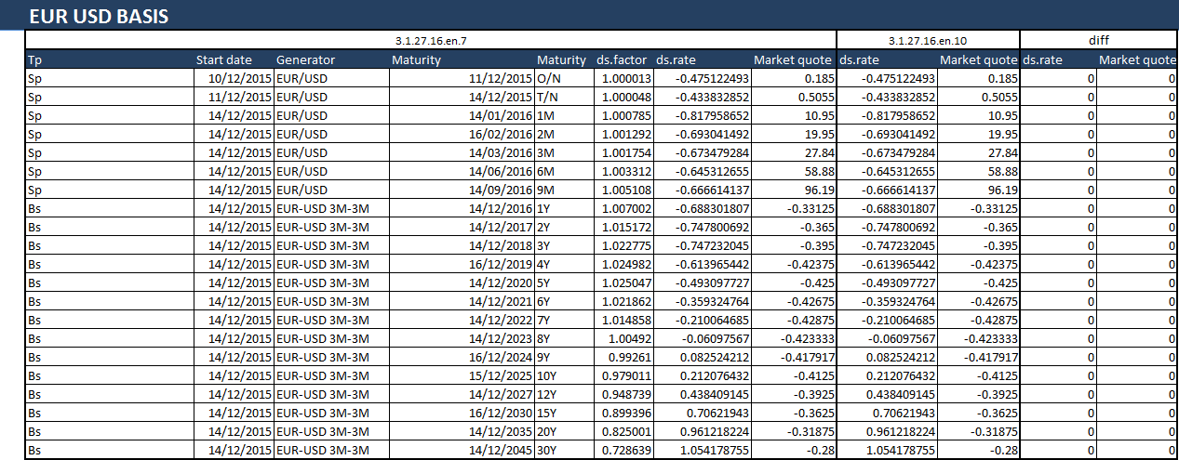

Figure : EUR USD BASIS calibration non regression matching results

Also some replication of the calibrated ZC and compared to Murex were done for some curve pillars.

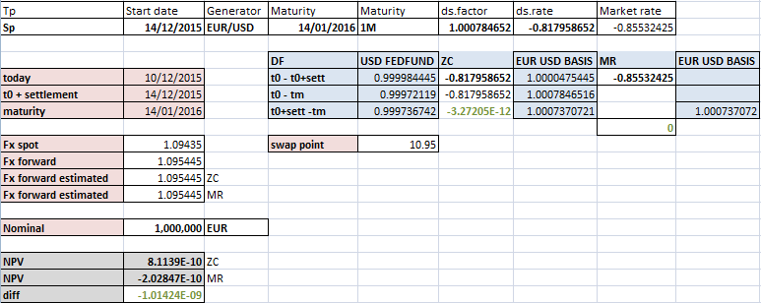

Figure : ZC replication for 1M pillar matching results

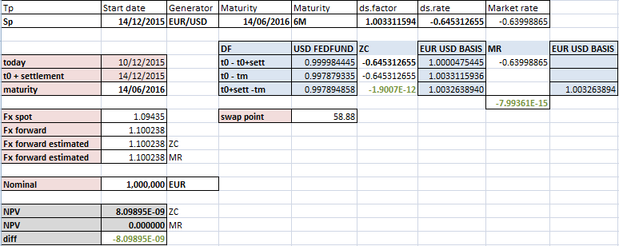

Figure : ZC replication for 6M pillar matching results

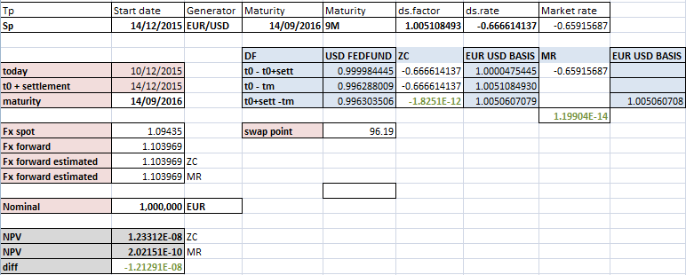

Figure : ZC replication for 9M pillar matching results

## Cross currency basis curve Jacobean

### Version 3.1.27.16.en.7 Jacobian issue

In this version, the Jacobian was wrong for the Swap point

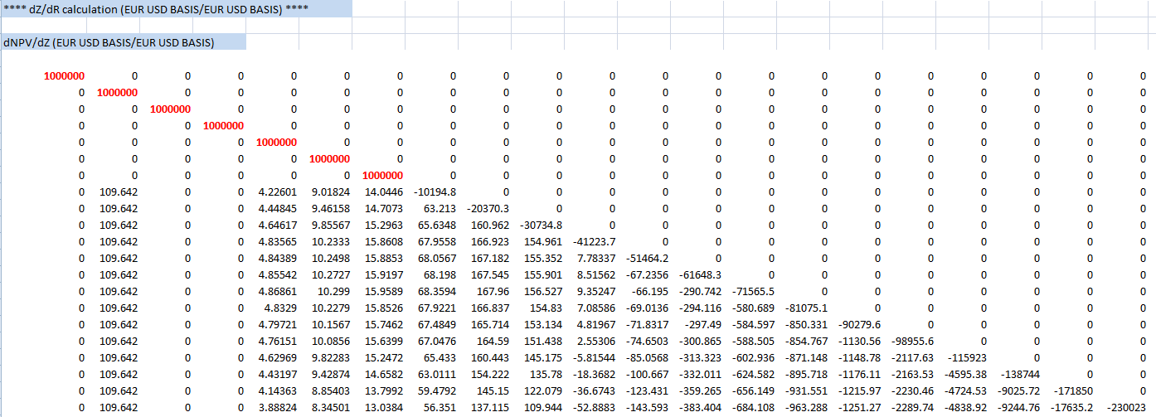

Figure : EUR USD BASIS dNPV/dZ Swap point issue

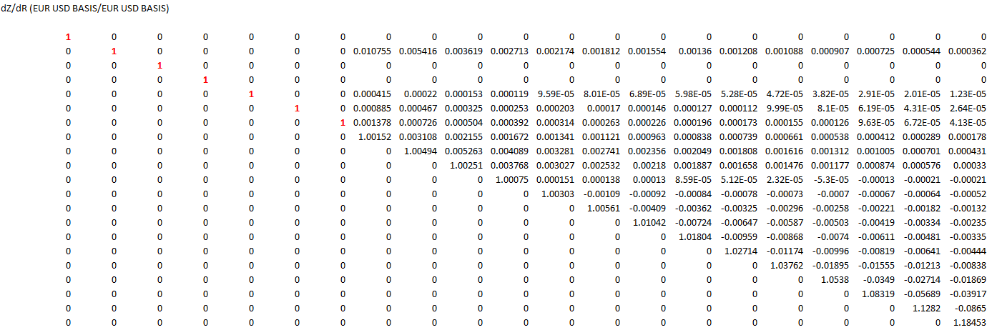

Figure : EUR USD BASIS dZ/dR Swap point issue

### Version 3.1.27.16.en.10 Jacobian correction

In the new patch 3.1.27.16.en.10 , the Jacobian was corrected as displayed below

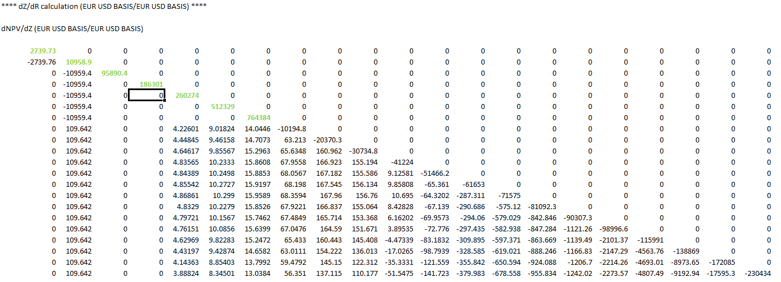

Figure : EUR USD BASIS dNPV/dZ Swap point correction

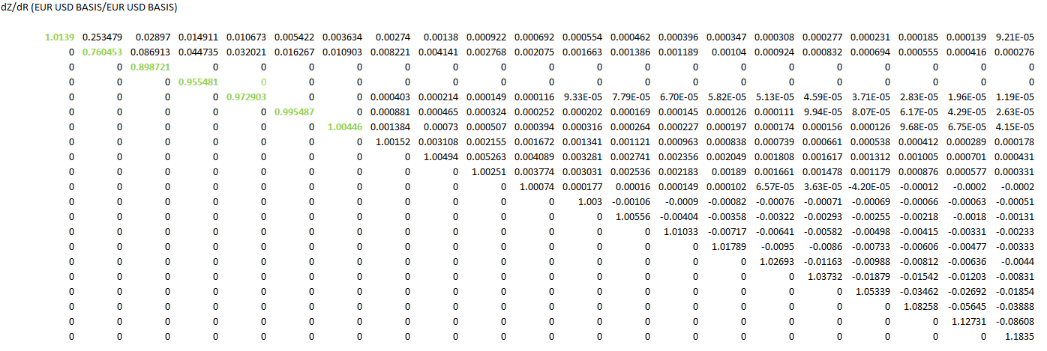

Figure : EUR USD BASIS dZ/dR Swap point correction

A replication of the Jacobian matrix was done as well for a Simplified EUR USD Basis curve containing only Swap points.

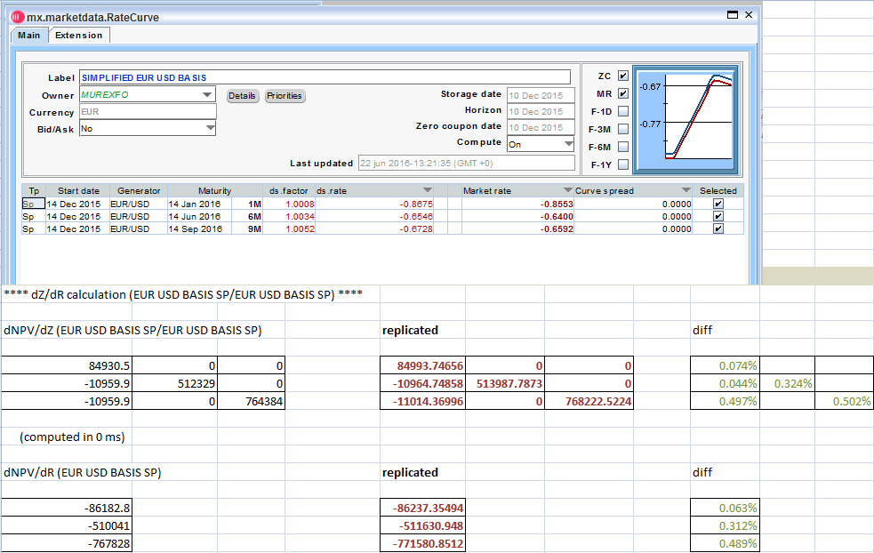

Figure : EUR USD BASIS Simplified curve Jacobian matching results

## Resettable cross currency basis swap (Float-Float)

### Trade definition

The trade is a EUR- USD 3M-3M resettable on the USD leg.

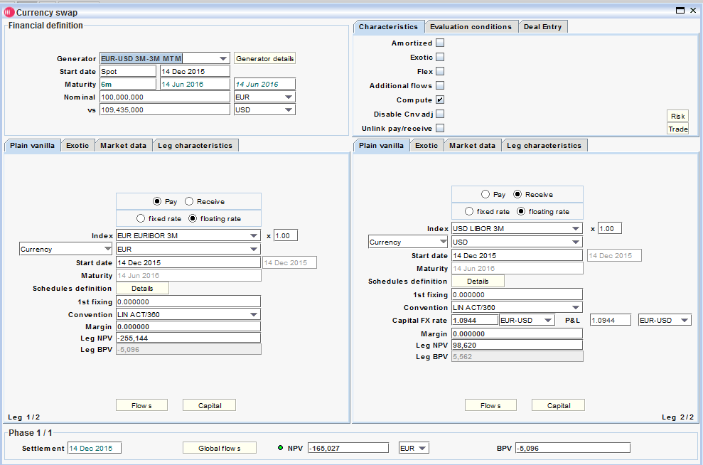

Figure : EUR-USD 3M-3M MTM trade definition

Trade date is 10/12/2015 and the first spot date FX rate is 14/12/2015

### NPV

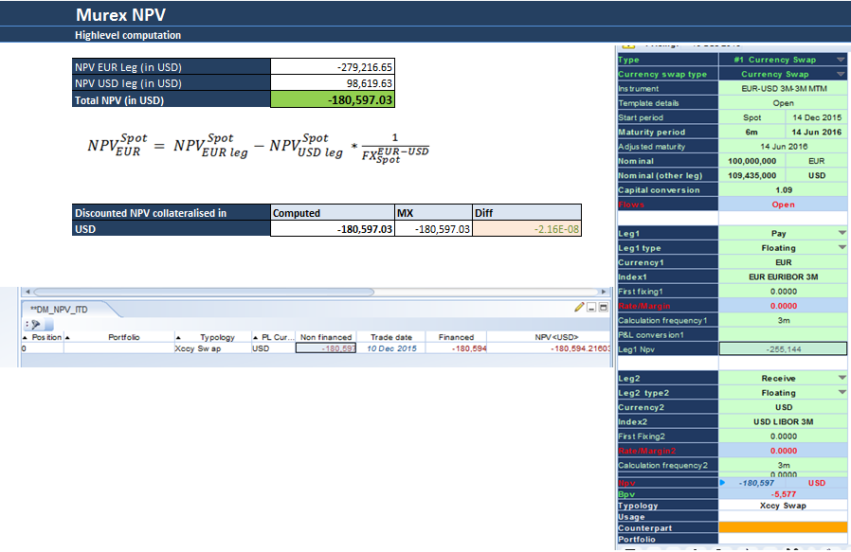

Figure : EUR-USD 3M-3M MTM NPV matching results

7.4.3 Discount IR risk EUR leg

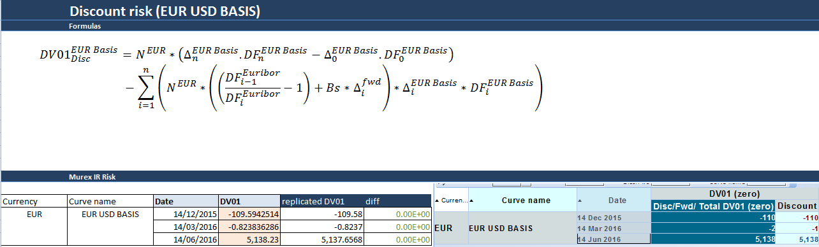

Figure : EUR-USD 3M-3M MTM Discount DV01 EUR leg matching results

7.4.4 Forward IR risk EUR leg

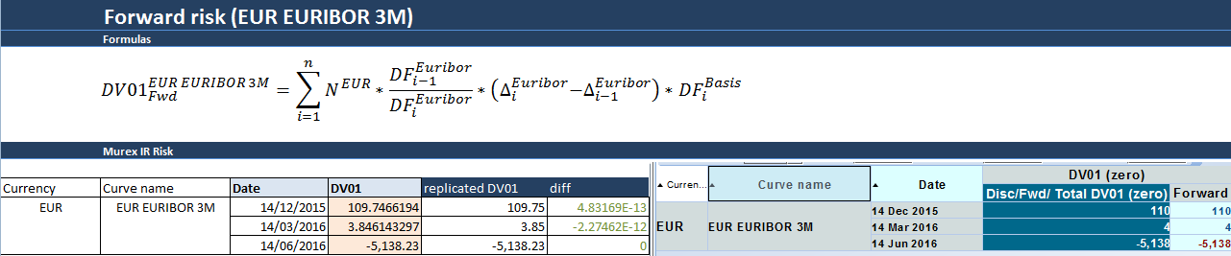

Figure : EUR-USD 3M-3M MTM Forward DV01 EUR leg matching results

7.4.5 FX spot conversion IR risk EUR leg

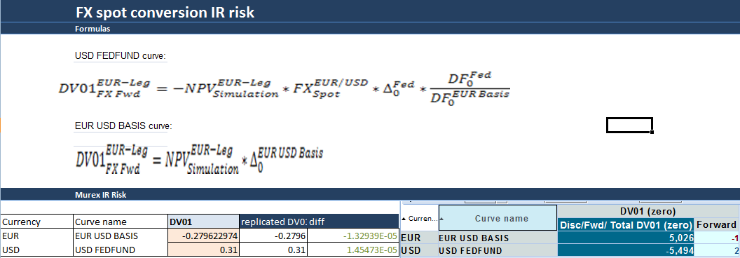

Figure : EUR-USD 3M-3M MTM FX spot conversion DV01 EUR leg matching results

7.4.6 Discount IR risk USD leg

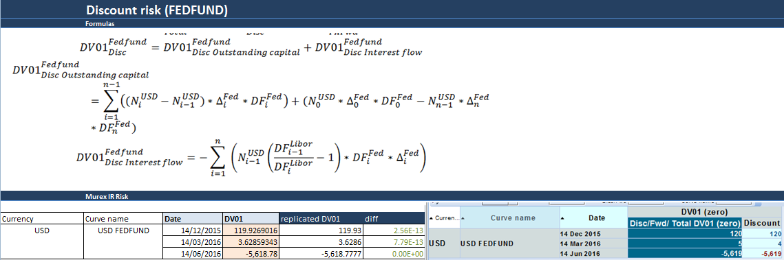

Figure : EUR-USD 3M-3M MTM Discount DV01 USD leg matching results

7.4.7 Forward IR Risk USD leg

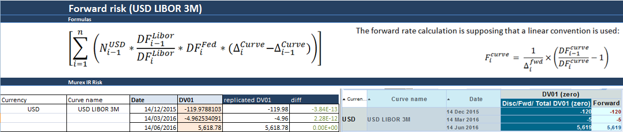

Figure : EUR-USD 3M-3M MTM Forward DV01 USD leg matching results

7.4.8 FX Fwd IR risk USD leg

Doing the comparison, we can see we are matching the sensitivities on all curves. There is a very small noise on EUR USD basis but it is very small to be ignored

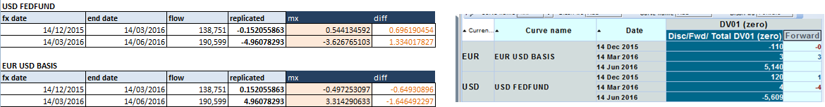

Figure : EUR-USD 3M-3M MTM FX Fwd DV01 USD leg matching results

7.4.9 PV01

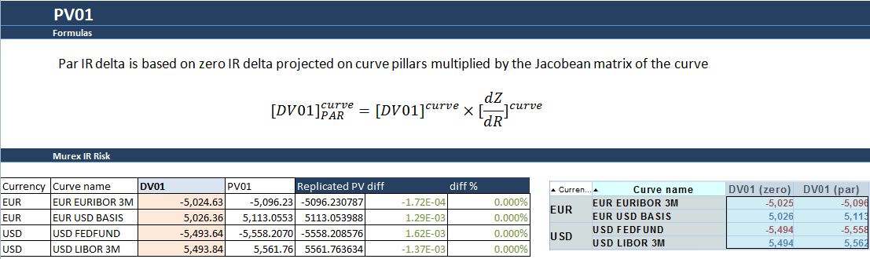

Figure : EUR-USD 3M-3M MTM PV01 matching results

7.4.10 FX delta EUR leg

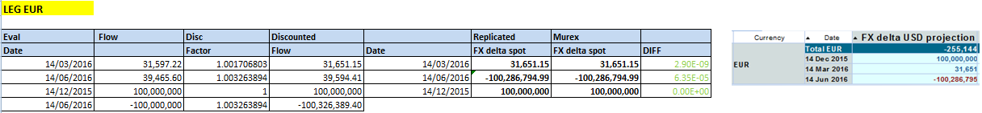

Figure : EUR-USD 3M-3M MTM FX delta EUR leg matching results

7.4.11 FX delta USD leg

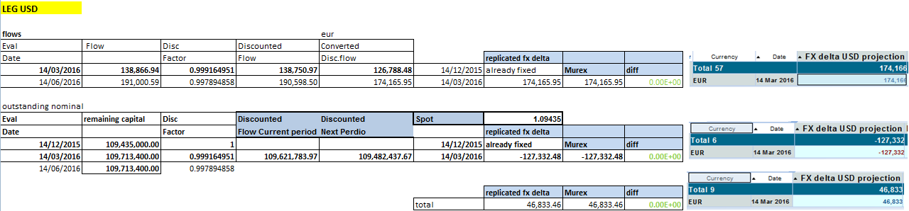

Figure : EUR-USD 3M-3M MTM FX delta USD leg matching results

## 7.5 Cross currency basis swap (Fix-Fix)

A non regression tests were done in 3.1.27.16.en.10 to check that case 4.1 has still the same NPV and risk figures as in version 3.1.27.16.en.7 .

7.5.1 NPV

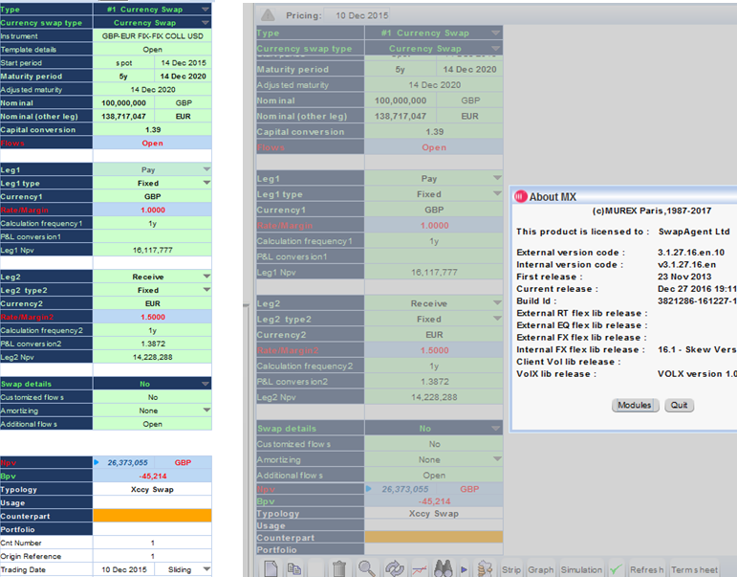

Figure : GBP-EUR FIX-FIX between versions NPV matching results

7.5.2 IR Risk

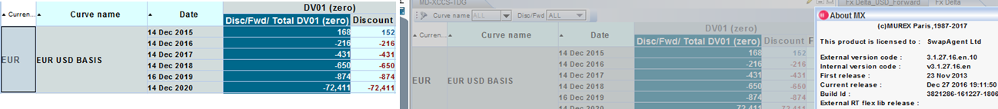

Figure : GBP-EUR FIX-FIX between versions DV01 EUR leg matching results

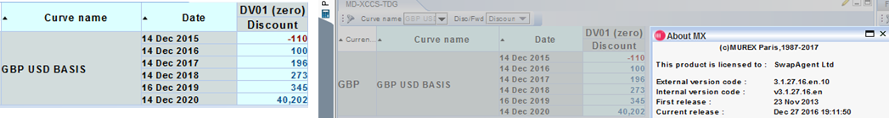

Figure : GBP-EUR FIX-FIX between versions DV01 USD leg matching results

7.5.3 FX delta

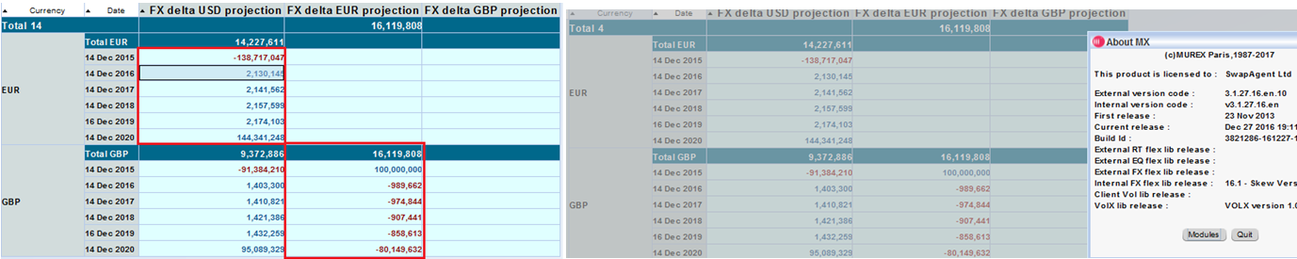

Figure : GBP-EUR FIX-FIX between versions FX delta matching results

## Non regression tests with the slash

**Previous configuration:** to avoid having cross sensitivities in the simulation risk figures, the “default entry setting” of the cross currency basis curve has to be set to *Zero coupon*- this solves the issue but this setting has to stay *market rates.*

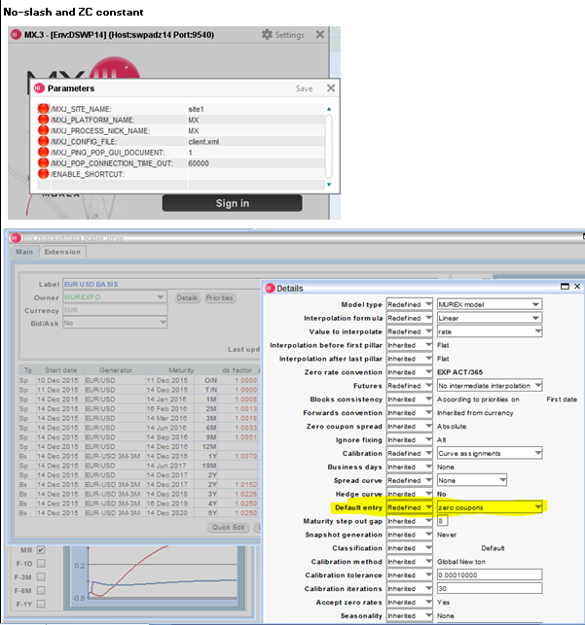

Figure : No-slash and default entry set to zero coupon

**New configuration:** In the version v3.1.27.16.en.10 thanks to the slash /XCCY_SENSIS_FOLLOW_PROPAGATION:, the default entry setting can stay market rates and no cross sensitivity will be displayed in the simulation

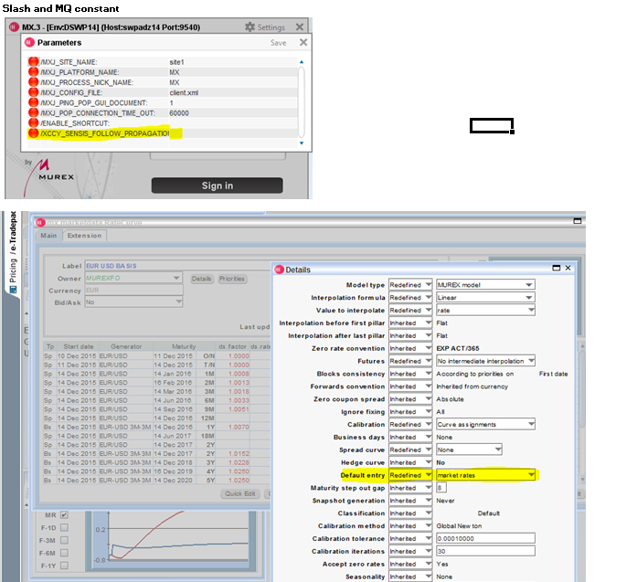

Figure : Slash and default entry set to market rates

### Results

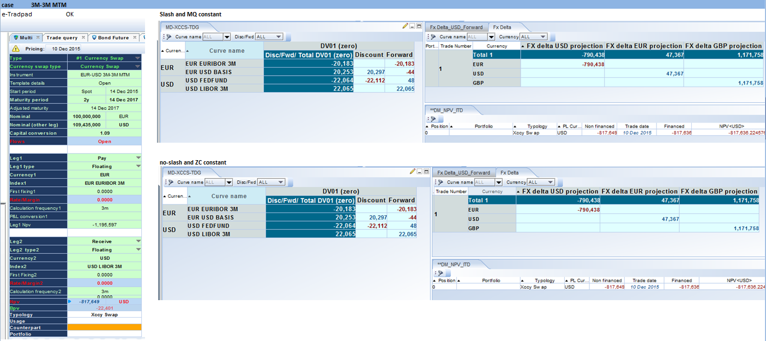

Figure : EUR-USD 3M-3M MTM with both settings configuration matching results

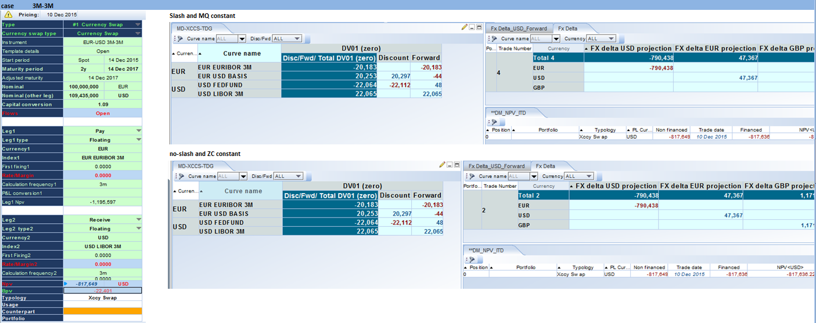

Figure : EUR-USD 3M-3M with both settings configuration matching results

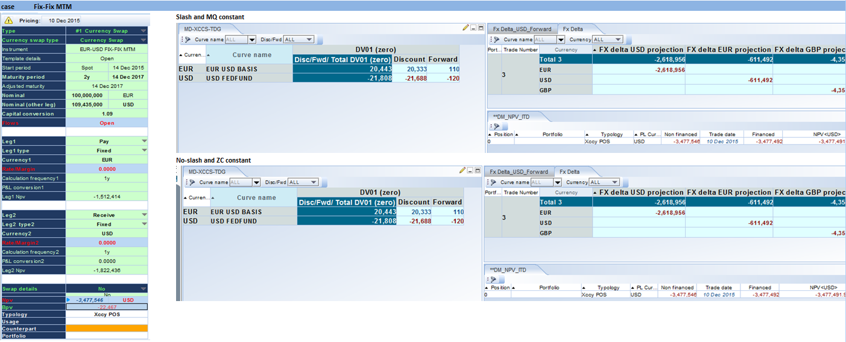

Figure : EUR-USD FIX-FIX MTM with both settings configuration matching results

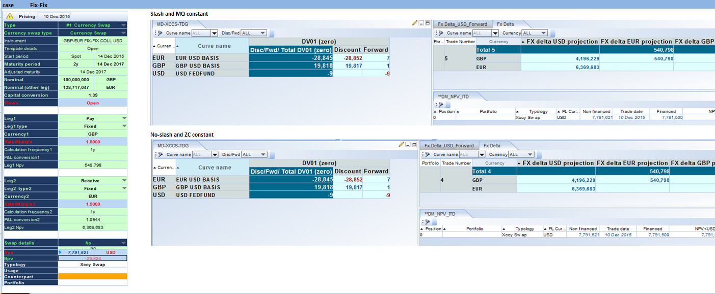

Figure : GBP-EUR FIX-FIX with both settings configuration matching results

# Appendix 1 – List of closed Murex cases

|  |  |  |  |
| --- | --- | --- | --- |
| **MX Case #** | **Severity** | **Description** | **Solution** |
| **592658** | **High** | XCCS: unexpected sensitivities on the libor curve | in v27, use default entry set to zero coupon in curve setting |
| **604055** | **High** | Top of Form  Fixing procedure not called at fixing date for FX  Bottom of Form | Solved using the PayFix Window script |
| **604053** | **Normal** | Several noises and new sensitivities dates in risk calculation | Extra DV01 risk was coming from cross currency cross sensitivities. Configuration change provided in #592658 solves this issue |
| **604023** | **Normal** | Xccs POC-STD curve called in Basis curve | This dependency is fixed in v36 but does not impact valuation and sensitivities |
| **611171** | **Low** | Collateral based discounting documents | Documents list provided |
| **596206** | **Low** | Xccy: Information request Murex Taylor VaR capabilities | Both option exists |
| Top of Form  **593134**  Bottom of Form | **Low** | FX delta: view configuration | No official document |

# Appendix 2 – Basis curve defined as a spread curve

Defining basis curves as spread curves over OIS curves is not considered in the scope. A test has however been done in order to check how the evaluation and the risks behave.

EUR-USD Basis curve has been defined as spread curve over EUR EONIA curve, instead of being an outright one.

The evaluation and FX delta does not change; below screenshots show IR risk comparison for the GBP-EUR Fixed-Fixed cross currency basis swap:

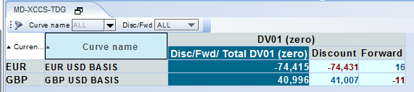

Figure : IR risk with basis curve defined as an outright curve

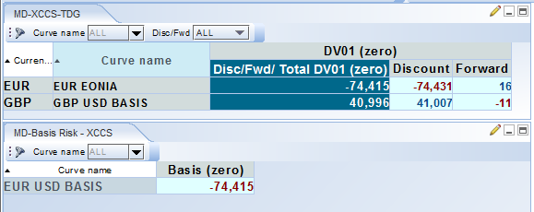

Figure : IR risk with basis curve defined as a spread curve

The IR discounting risk is the same and now projected on EUR EONIA, and a basis risk (or a spread risk) close to the IR discounting risk appears on the EUR USD Basis curve.